October 2021
Oregon’s
Mid-Coast Water Actions
2022–2032
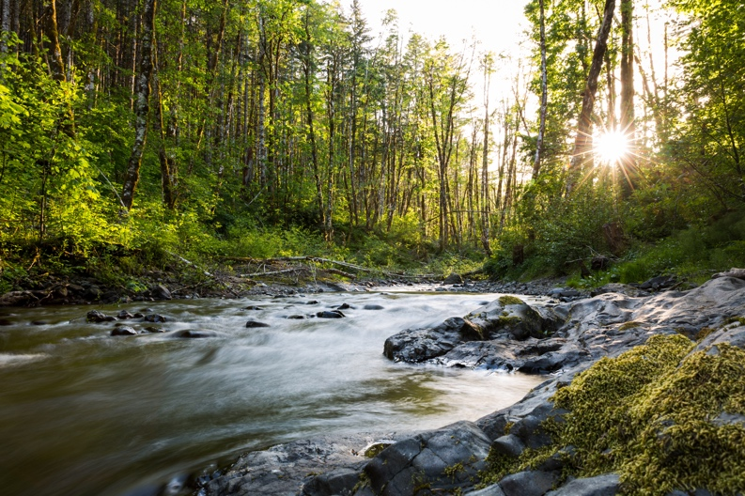
Mid-Coast Water Planning Partnership
October 2021

This page intentionally left blank.

Table of Contents

Table of Contents iii
List of Figures v
Acknowledgements vi
A Message from the Co-conveners 1
Executive Summary 2

The Mid-Coast Water Planning Partnership 3
Mission, Vision, and Goals of the Partnership 3
Mission 3
Vision 3
Goals 3
History and Drivers of the Planning Process 4
Geographic Scope 7
Guiding Principles 8
How this plan intersects with other regional planning efforts 9
Environment, Natural Resources, and Economy of Oregon’s Mid-Coast 11
General Overview 11
Perceptions and Values of Mid-Coast Regional Stakeholders 12
Climate Vulnerability in the Mid-Coast 15
Water Rights in the Mid-Coast 16
Understanding Water Resources Quantity, Quality, and Ecological Issues 17
Water Quantity 17
Surface Water 18
Water Quality 18
Water Quality Monitoring 20
Water Quality Impaired Streams in the Mid-Coast 20
Groundwater Quality 20
Ecology 21
Habitats in the Mid-Coast 21
Species and Habitat Needs 22
Aquatic Habitats 23
Wetland Habitats 26
Mid-Coast Areas of Ecological Importance 26
Habitat Degradation 26
Action Plan Overview 28
Action Plan Development 28
Key Water Issues 28
Drivers 29
Overview of the Strategic Action Imperatives 31
Performance Metrics 31
Implementing the Water Action Plan 32
Imperative 1. Public Awareness and Support 33
Objectives: 33
Action Details 33
Performance Metrics 36
Metric Methodology 36
Imperative 2. Regional Capacity and Collaboration 37
Objectives 37
Action Details 37
Performance Metrics 38
Metric Methodology 39
Imperative 3. Monitoring and Data Sharing 40
Objectives 40
Action Details 40
Performance Metrics 41
Metric Methodology 41
Imperative 4. Water Conservation, Efficiency and Reuse 42
Objectives 42
Action Details 42
Performance Metrics 43
Metric Methodology 43
Imperative 5. Resilient Water Infrastructure 44
Objectives 44
Action Details 44
Performance Metrics 47
Metric Methodology 47
Imperative 6. Source Water Protection and Water Supply Development 48
Objectives 48
Action Details 48
Performance Metrics 50
Metric Methodology 51
Imperative 7. Ecosystem Protection and Enhancement 52
Objectives 52
Action Details 52
Performance Metrics 56
Metric Methodology 57
Literature Cited 58
Appendices 60
Appendix A: Definitions 61
Appendix B: Snapshot ecological summary of the major basins in the Mid-Coast. 65
Salmon River Ocean Drainage Area 65
Siletz Bay Ocean Drainage Area 66
Siletz River Ocean Drainage Area 67
Depoe Bay Ocean Drainage Area 69
Yaquina River Ocean Drainage Area 70
Beaver Creek Ocean Drainage Area 72
Alsea River Ocean Drainage Area 73
Yachats River Ocean Drainage Area 75
Appendix C: Crosswalk of the Mid-Coast Water Planning Partnership Plan actions with other important regional conservation plans. 78
Appendix D: Water providers by population served and connections. 81
Appendix E: Mid-Coast Water Planning Partnership Step 2 Reports on Water Quality, Quantity, and Ecology in the Mid-Coast of Oregon. 82
Appendix F. User’s Guide to Oregon Explorer. 83

List of Figures
Figure 1. Water cycle diagram. NASA/JPL Flickr (CC BY 2.0).
Figure 2. Water cycle diagram. Ehud Tal - Own work, CC BY-SA 4.0, https://creativecommons.org/licenses/by-sa/4.
Figure 3. The five steps of the planning process, September 2016–November 2021.
Figure 4. The six-step planning process to realize and implement an integrated water management plan for Oregon's Mid-Coast.
Figure 5. The geographic scope of the MCWPP includes eight watershed basins.
Figure 6. Word graphic illustrating the elements of a successful planning process based on sound guidance principles.
Figure 7. A snapshot of the environment, natural resources, and economy of Oregon's Mid-Coast.
Figure 8. Graphic illustrating key values and perspectives of Mid-Coast stakeholders in 2018 survey.
Figure 9. Predictions of climate change stressors in the Mid-Coast region of Oregon.
Figure 10. Volume of surface water in streams, rivers, and basins in the Mid-Coast.
Figure 11. Illustration depicting the nexus between the Mid-Coast Water Planning Partnership Water Action Plan and other key conservation plans in the region.

Acknowledgements

To obtain a copy of this document go to https://www.midcoastwaterpartners.org

Recommended Citation:

A Message from the Co-conveners

Executive Summary

The Mid-Coast Water Planning Partnership
The Mid-Coast region of Oregon is one of four areas that began piloting a new approach to water planning in 2016 with the Oregon Water Resources Department (OWRD). The purpose of the place-based integrated water resources planning efforts was to advance Oregon’s 2012 Integrated Water Resources Strategy, which directs OWRD to help communities collaboratively develop solutions to address water challenges within a geographic scope defined by stakeholders.
This plan – Mid-Coast Water Planning Partnership Water Action Plan – represents the cumulative work of the Mid-Coast Water Planning Partnership (MCWPP), or the Partnership, and serves as a living document to provide the Partnership the ability to amend its actions to achieve its goals as time and circumstances change. Definitions fundamental to this plan are in Appendix A.

Mission, Vision, and Goals of the Partnership

Mission
The purpose of the Mid-Coast Water Planning Partnership is to develop an inclusive community forum that examines water use in the region, identifies current and potential water challenges, and creates a unified plan to balance water needs.

Vision
Regional partners ensuring balanced water resources for the environment, the economy, and coastal communities.

Goals
Work collaboratively to develop an Integrated Water Resources Plan for the Mid-Coast Region:
- Develop a sustainable water supply for consumptive uses that also protects the environment, supports healthy watersheds, and is resilient to climate change stressors and natural hazards.
- Balance the needs of our ecosystems, our economies, and our communities.
- Develop cross-boundary solutions that help neighbors work together to achieve additive effects.
- Develop and implement integrated regional water management strategies for improved water quality and quantity as well as provide fair access.
- Increase awareness about regional water needs, challenges, and opportunities.
- Improve the resilience of water management infrastructure by identifying emergency water sources and taking steps to access those water resources when needed, and repair water system infrastructure.

History and Drivers of the Planning Process
The Mid-Coast water planning initiative launched in 2016 with a grant from OWRD to the City of Newport to convene a collaboration of stakeholders and develop strategies, over a 3-year period, that would:
- Address aging infrastructure, improve water conservation efforts, enhance regional water supply options, and more effectively share water among uses and users;
- Relieve late season pressure on rivers, streams, and tributaries while meeting water needs for industries and coastal communities;
- Create redundancies to enhance resilience during drought, storms, and other natural vulnerabilities; and
- Create a learning and action network for small water providers vulnerable to environmental and regulatory challenges.
Key Water Supply Challenges
Water suppliers struggle to meet existing demands, and it was projected in 2016 that water suppliers would be unable to meet demand by 2020.
Low summer stream flows and limited water storage create water shortages for both communities and stream flows critical for fish, recreation, and industry.
Regional communities need to be better prepared to address natural hazards, vulnerabilities, and emergency preparedness.
During its first meeting, the Mid-Coast water planning initiative became the Mid-Coast Water Planning Partnership. The Partnership is formed as a voluntary association that actively seeks to include diverse perspectives, interests, and expertise regarding water issues on the Mid-Coast. Organizations or individuals may join the Partnership at any time by agreeing to the terms of the Charter. The Partnership seeks to include, but not be limited to, representation and input from municipal water providers; special districts/water districts; industrial water users; local businesses and economic development organizations; coastal residents, rural homeowners, and landowners; conservation/environmental organizations; timber/forestry groups; agricultural groups; fishing groups; recreation groups, academic/scientific community; city and county governments; state and federal agencies; tribes; and, elected officials. For an updated list of members, see https://www.midcoastwaterpartners.com.
In its first meeting in September of 2016, the Partnership stated that its purpose was to examine water supply and demand needs in Oregon’s Mid-Coast region because of three key water supply challenges: (a) water suppliers struggle to meet existing demands, and it was projected in 2016 that water suppliers would be unable to meet demand by 2020; (b) low summer stream flows and limited water storage create water shortages for both communities and stream flows critical for fish, recreation, and industry; and, (c) regional communities need to be better prepared to address natural hazards, vulnerabilities, and emergency preparedness.
During the September 2016 MCWPP kickoff meeting, stakeholders articulated desired outcomes for their planning process. The outcomes included:
- Increased awareness about regional water needs, challenges, and opportunities.
- Development of cross-boundary solutions that help neighbors work together to achieve additive effects.
- Integrated regional water management strategies that are planned and implemented to improve water quality and quantity, ensuring fair access.
- Sustainable water supply for consumptive uses while protecting ecological needs.
- Improved resilience.
- Flow management to store more water and raise the water table to alleviate summer low-flows.
- Incentives for water conservation.
- Enhanced understanding of the role of existing rules, regulations, and resources associated with water management and use.
- Water rights that benefit everyone.
A process that is timely, is multi-decadal in its vision, and is foundational to obtaining additional sources of funding for implementation. The Partnership determined it would realize a vision for its plan in five steps. A sixth step was added in 2020 by the facilitation team that ultimately developed this plan to acknowledge the importance of incorporating adaptive management principles as the plan is implemented (Figure 1).
The first step was conducted from September 2016–May 2017, and included convening partners to initiate the planning process, developing a work plan and schedule, and creating an inclusive process. The partnership charter, which defines the purpose and goals of the Partnership, and documents how members agree to work together, was adopted March 29, 2017.
The second step was conducted from May 2017–February 2018 and included producing technical reports characterizing the Mid-Coast’s water quantity, water quality, ecology, and built systems.
The third step was conducted from February 2018–September 2020, and included convening three working groups to articulate current and future water needs and affirming and finalizing 18 key issue statements in eight categories.
The fourth step was conducted from September 2020–June 2021, and included developing and launching a new website and drafting the plan. Specific strategies that address each key issue were identified and prioritized, and performance metrics were developed to assess progress implementing strategies.
The fifth step was conducted from June 2021–November 2021, and included a review of the plan by stakeholders and incorporation of edits.

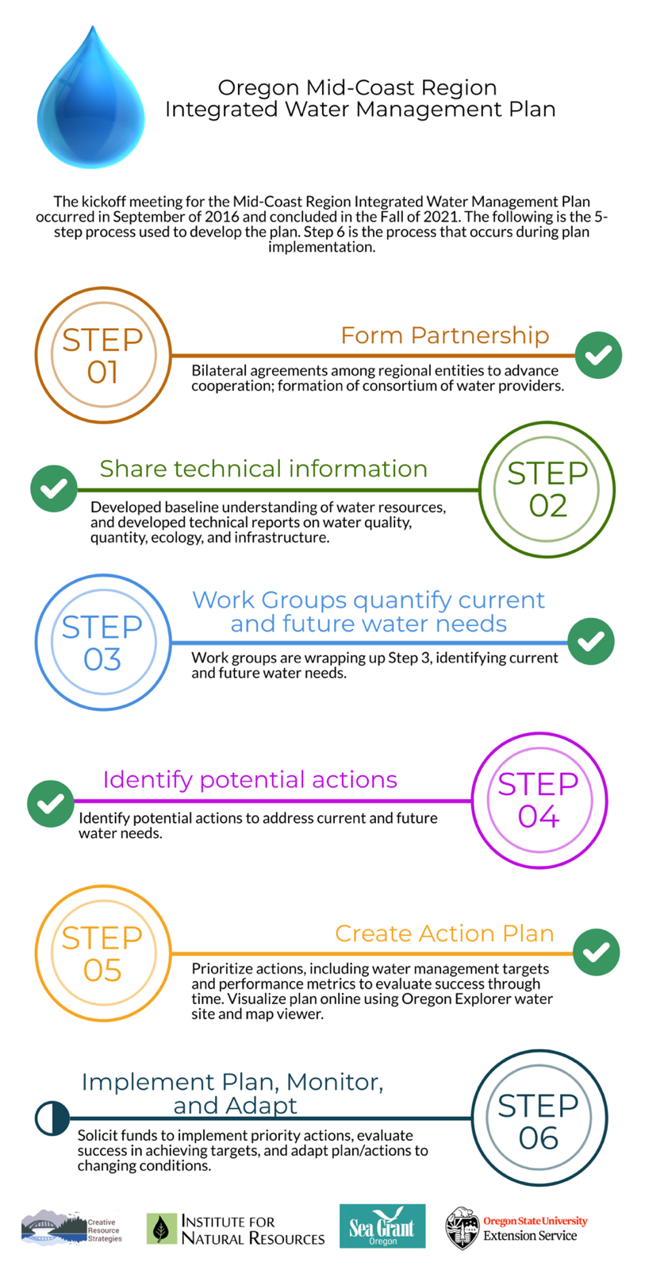

Figure 1. The six-step planning process to complete an integrated water management plan for Oregon's Mid-Coast.

Geographic Scope
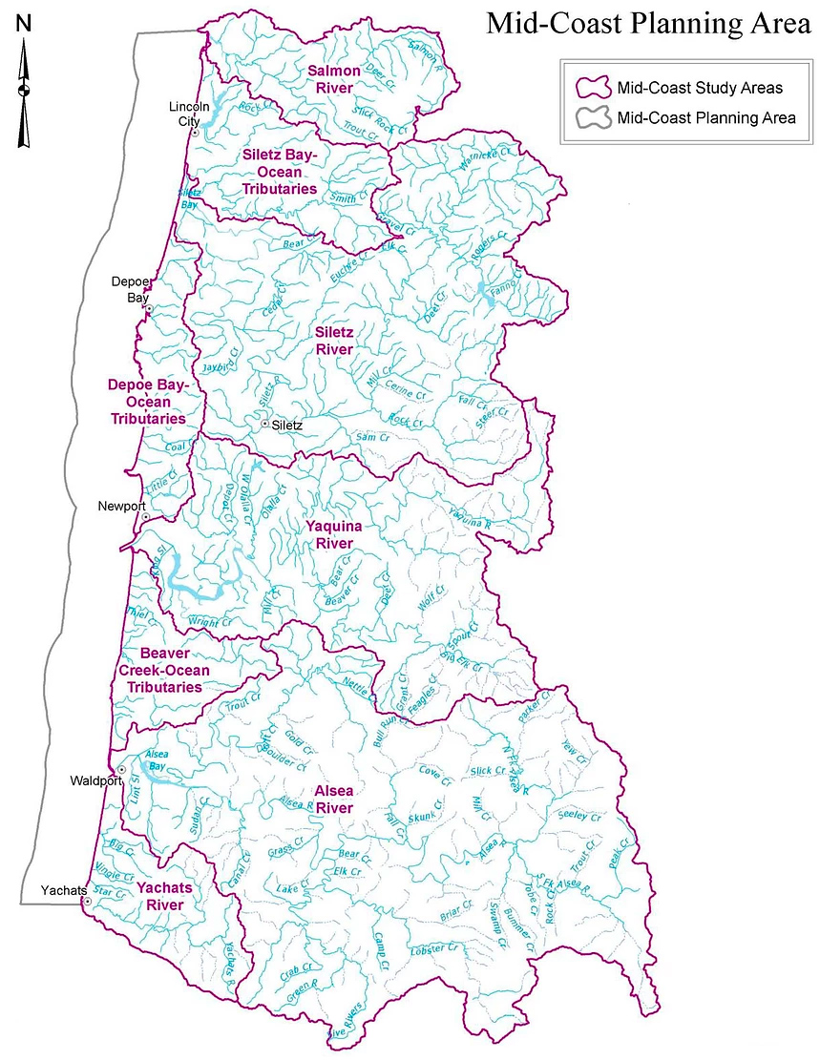
At the September 2016 Partnership kickoff meeting, the geographic scope of this initiative was originally described as Lincoln County to achieve a successful outcome and serve as a model. The current geographic scope includes the Salmon River, Siletz Bay-Ocean Tributaries, Siletz River, Depoe Bay-Ocean Tributaries, Yaquina River, Beaver Creek-Ocean Tributaries, Alsea River, and Yachats River basins (Figure 2). An ecological snapshot summary of each of these basins can be found in Appendix B.
Figure 2. Mid-Coast planning area.
Figure 2. The six-step planning process to complete an integrated water management plan for Oregon's Mid-Coast.

Guiding Principles
The Partnership also identified the key values to guide how its members would work together as a partnership to achieve goals. Figure 3 illustrates some of the common elements of a successful strategic planning process.
- Partnership. We recognize different perspectives and seek common ground to develop strategies that meet our collective needs.
- Transparency. We create an inclusive process to openly share information and interests, invite curiosity, and encourage dialogue.
- Innovation. We bring our best ideas and information to the table and explore innovative, out-of-the-box solutions.
- Commitment. We act in good faith to support the success of the Partnership in developing strategies that are in the best interests of the region.
- Flexibility. We are open to new ideas and approaches that will adapt our process or approach to fit the needs of the Partners.
- Action. We seek practical near-term actions as well as longer term strategies consistent with our goals.

- Clarity. We commit to expressing all of our findings in the simplest and clearest form possible.
Figure 3. Word graphic illustrating the elements of a successful planning process based on sound guidance principles.

How this plan intersects with other regional planning efforts
This action plan is intended to achieve water objectives critical to people living and working in the Mid-Coast region of Oregon. It is also intended to supplement, complement, and support numerous other planning efforts currently underway in the region, especially those that address water issues foundational to the Mid-Coast Water Planning Partnership (see Appendix C for a crosswalk of these efforts with this plan). These regional planning efforts include, but are not limited to, the:
- Final Endangered Species Act Recovery Plan for Oregon Coast Coho Salmon (Oncorhynchus kisutch). The goal of this plan is to improve the viability of Oregon Coast Coho, and the ecosystems upon which it depends, to the point that they no longer require Endangered Species Action protection. The recovery direction for Oregon Coast Coho Salmon is to protect and restore the freshwater and estuarine rearing habitats that support juvenile survival and overall productivity.
- Oregon Watershed Enhancement Board Focused Investment Partnership goals as they related to Aquatic Habitat for Native Fish Species and Coho Habitat and Populations Along the Coast—The Oregon Watershed Enhancement Board Focused Investment Priority for Inland Aquatic Habitat for Native Fish Species guides voluntary actions that address limiting factors related to the protection and restoration of the watershed functions and processes in this habitat type. Initiatives within this priority identify the primary limiting factors outlined in associated federal recovery, state conservation, or tribal plans that the initiative is aiming to address, and are guided by the habitat and population objectives and conservation approaches set forth in these plans. Focal areas for this priority are defined as those native fish habitats in Oregon that are identified as priorities in associated federal recovery, state conservation, or tribal plans. Voluntary restoration and conservation actions are especially encouraged in locations where investments will also address identified non-point source water-quality concerns.
- Lincoln County Multi-Jurisdictional Natural Hazards Mitigation Plan. This plan describes priority natural hazards of concern to the Mid-Coast region, including coastal erosion, drought, earthquakes, floods, landslides, tsunamis, wildfire, windstorms, and winter ice. Although there is no direct relationship to the actions within the Mid-Coast Water Planning Partnership Water Action Plan, any efforts that reconnect floodplains, restore stream flow, and restore riparian areas will enhance resilience of the Mid-Coast region to climate change stressors and several natural hazards. In addition, three actions within this plan have a nexus with natural hazards.
- Lincoln County Climate Action Plan—This plan emphasizes water supply resiliency measures that reduce water use by developing focused, interrelated water conservation measures, regulations, education, and incentives.

Environment, Natural Resources, and Economy of Oregon’s Mid-Coast

General Overview
About 50,000 people live in the Mid-Coast region of Oregon. The human population is estimated to grow by about 10,000 people in the next 40 years, but rate of population growth is expected to decline. The projected demographic shift is towards older population.
Land use is primarily private, state, and federal forests (96.5%). Other land uses include livestock grazing, rural residential development, and urban development.
The economy is comprised of personal income, pensions, investments, tourism, and natural resources. The natural resources economy consists of commercial fishing (40%), tourism (33%), timber (26%), and to a lesser extent agriculture (1%).
Stream flows are rain-dominated. Most precipitation occurs November–March, and dry conditions occur in the summer. Groundwater aquifers have low yield and poor storage capacity.
Water use and rights. There are 52 potable water providers (Appendix D), 31 of which are required to have certified water treatment plant operators. A total of 14 entities (cities, resorts/hotels, and industries) have permits to discharge treated wastewater. A total of 42 streams have existing instream water rights.
Conservation Opportunity Areas. Of the 206 designated Conservation Opportunity Areas (COAs) in Oregon, seven of them are within Oregon’s Mid-Coast region: Siletz Bay-Ocean COA, Siletz River COA, Depoe Bay Area COA, Yaquina Bay COA, Beaver Creek COA, Alsea Estuary-Alsea River COA, and Yachats River Area COA (Oregon Department of Fish and Wildlife 2020). Conservation Opportunity Areas are places where broad fish and wildlife conservation goals can best be met. Focusing investments in these areas can increase the likelihood of long-term success, maximize effectiveness over larger landscapes, improve funding efficiency, and promote cooperative efforts across ownership boundaries.
Estuaries. There are six major estuaries in the Mid-Coast: Salmon River, Siletz Bay, Yaquina Bay, Beaver Creek, Alsea Bay, and Yachats River Estuary.
Figure 4 provides a snapshot of the environment, natural resources, and economy of Oregon's Mid-Coast.

Perceptions and Values of Mid-Coast Regional Stakeholders
During 2018, Oregon’s Kitchen Table, a program of the National Policy Consensus Center in the College of Urban and Public Affairs at Portland State University, engaged 680 people that frequently visit, or work, live, or own a business in the Mid-Coast about their knowledge and values, interests, or concerns about the future of water in the region, and tradeoffs to consider as the MCWPP develops strategies to address key water issues and priorities (Oregon’s Kitchen Table 2019). Engagement strategies consisted of an online survey, a paper-based survey, and focus group sessions as well as direct mailing to Confederated Tribes of Siletz Indians households. A total of 505 people completed the online survey, 112 responded using the paper survey, 89% of participants self-identified as English speaking, and 11% self-identified as Spanish speaking. A total of 38 individuals representing the Confederated Tribes of Siletz Indians participated in the survey.

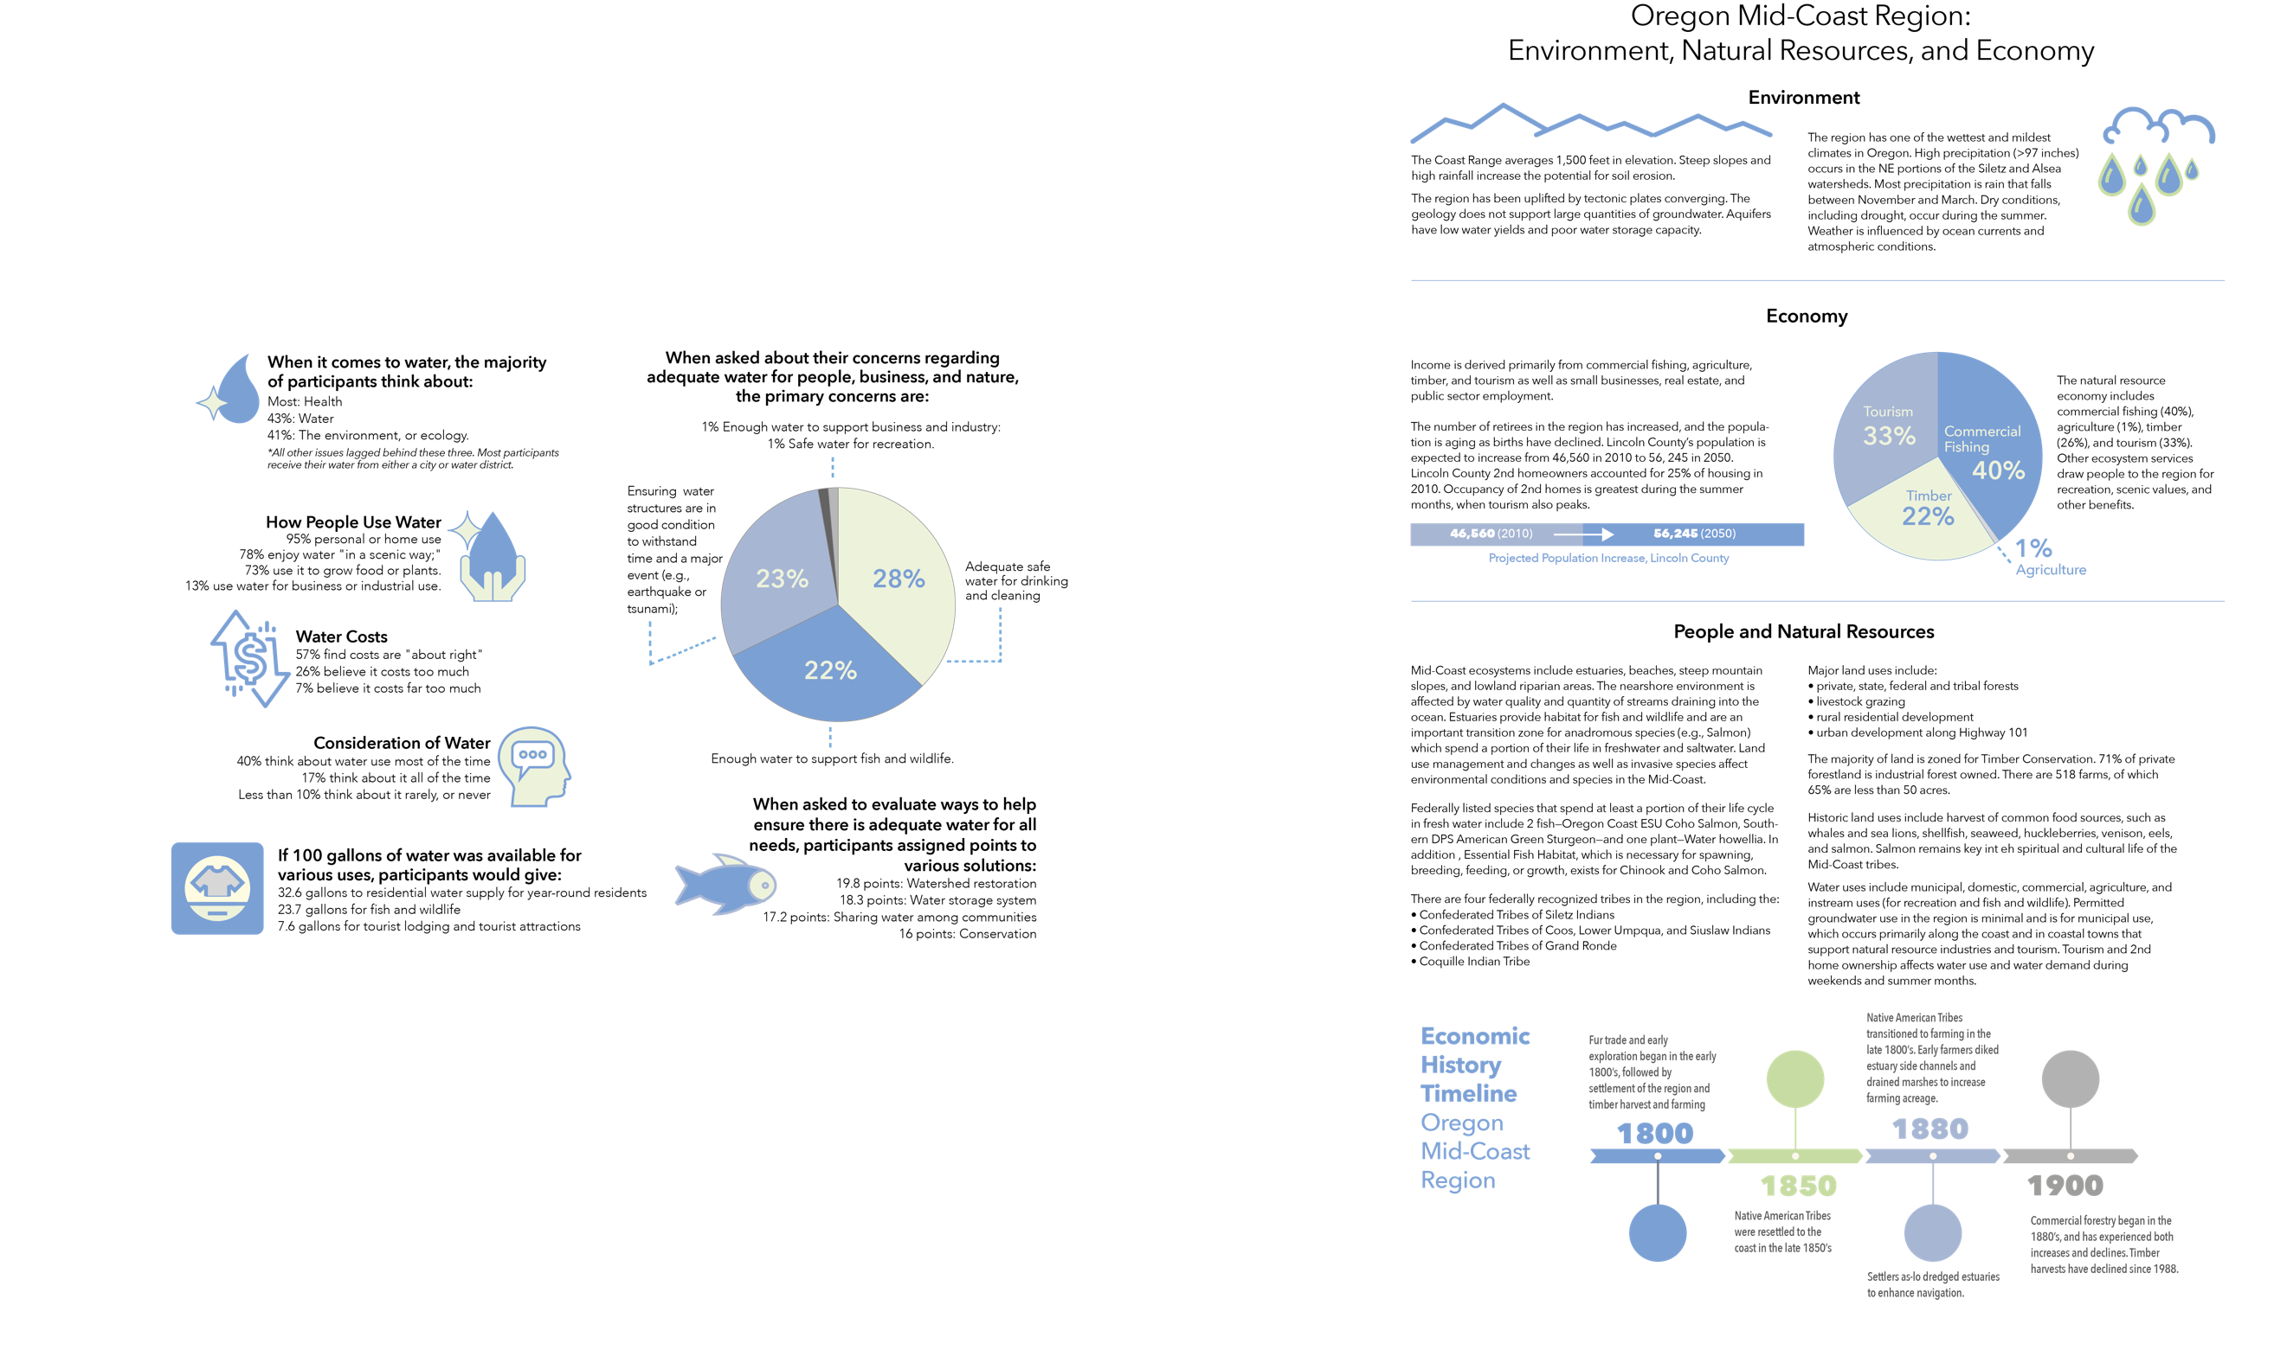
Figure 4. Snapshot of the environment, natural resources, and economy of Oregon's Mid-Coast.

The following commonly held values and beliefs were derived across all engagement strategies (Figure 5):
- The majority of participants listed health as the issue they think about either most, or next to most. A total of 43% of participants listed water as the issue they think about most, or next to most, and 41% listed environment or ecology. The other issues lagged behind those three.
- Most participants obtain their water from either a city or a water district.
- A total of 95% of participants use water for personal or home use (such as drinking, cleaning, and more).
- A total of 78% of participants indicated that they enjoy water “in a scenic way,” and 73% use it to grow food or plants. Far fewer participants reported that they use it for business or industrial use (13%).
- A majority (57 %) of participants say their water costs are “about right”. About a third of participants believe that their water costs too much (26%), or far too much (7%).
- The people who responded to the survey frequently think about water use across the region. More than 40% think about water use most of the time, whereas 17% think of it all of the time. By contrast, less than 10% of respondents think about it rarely or never. The vast majority of respondents did not know about the MCWPP before this survey.
- If survey participants could give 100 gallons of water to various uses, they say they would give the most water (32.6 gallons) to residential water supply for year-round residents. Water for fish and wildlife was listed second (23.7 gallons). Water for tourist lodging and tourist attractions would receive 7.6 gallons.
- When asked about being able to make sure there is water for people, business, and nature, the results were split across concern for household use, infrastructure, and fish and wildlife. A total of 28% of respondents reported that their primary concern is making sure there is enough safe water to drink and use for cleaning, whereas 23% reported their greatest concern was making sure that the region’s water structures (pipes, pumps, etc.) are in good condition to withstand time and a major event, such as an earthquake or tsunami. A total of 22% said their greatest concern was making sure there is enough water to support fish and wildlife. Far fewer people (1%) are most concerned about having enough water to support business and industry. Likewise, very few (1%) feel the biggest concern is that the water be safe for recreation.
- When asked to evaluate ways to help ensure that there is enough water for all needs, participants assigned points to various solutions. Watershed restoration or protection (protecting or improving the forests and lands the region’s water flows through) received the most points (19.8 points out of 100 possible points). Water storage systems (such as reservoirs) received 18.3 points, and conservation received 16 points. Sharing water among communities received the fewest points (7.2 points).

Climate Vulnerability in the Mid-Coast
Figure 5. Key values and perspectives of Mid-Coast stakeholders in 2018 survey.
The Oregon Climate Change Research Institute (2019) produced a report describing future climate conditions for the Mid-Coast relative to temperature, precipitation, snowpack, floods, droughts, wildfire, sea level, and coastal ocean conditions. Future projected conditions were based on at least 10 global climate models and numerous scenarios of global greenhouse gas emissions, and were made locally relevant by combining the outputs from the global models to historical observations, achieving a resolution of 2.5 miles x 2.5 miles on the landscape. Projections were made for the mid-21st century, the 2050s, and late 21st century, and the 2080s.
The report authors considered both lower and higher emissions scenarios based on available data and published literature. Lower emissions scenarios represent modest efforts to reduce global greenhouse gas emissions by mid-21st century whereas the higher emissions scenarios represent “business-as-usual” practices, i.e., greenhouse gas emissions continuing to increase through the 21st century (Oregon Climate Change Research Institute 2019).
The following are a few highlights from that report (Figure 6) that describe the likelihood of projected changes in environmental parameters important to the Mid-Coast region.
Figure 6. Projected changes in environmental parameters important to the Mid-Coast region.

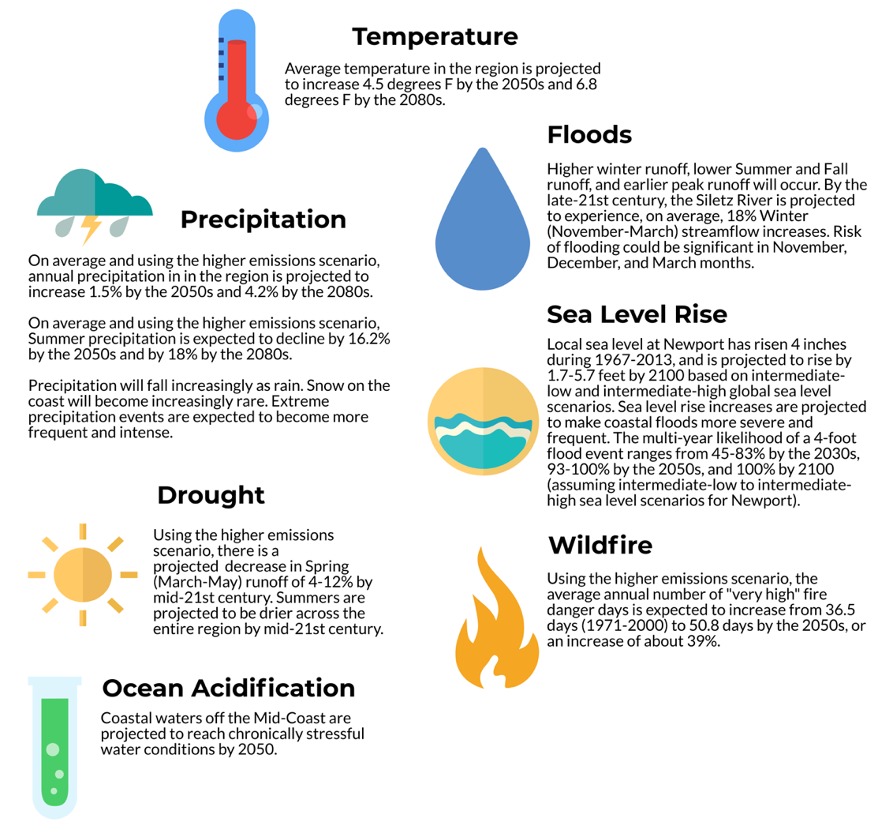
Water Rights in the Mid-Coast
In 1987, Oregon legally recognized instream uses as beneficial uses of water, allowing for the creation of instream water rights that authorize the use of water instream to protect aquatic ecosystems, and out-of-stream water rights to be transferred instream. Instream water rights protect a specified amount of flow be kept instream within a certain reach or at a specific point along a stream. They have a priority date, place of use, and rate just like any other water right. Typically, instream water rights allocate specified flows for each month in the year.
Oregon has three “families” of instream water rights.
- Instream water rights based on minimum perennial stream flows that OWRD administratively established in the 1950s and 1960s.
- Instream water rights that state agencies, primarily the Oregon Department of Fish and Wildlife (ODFW), applied for after the passage of the Instream Water Rights Act, which have priority dates later than 1987 and are typically junior to many existing water rights. The beneficial use for these water rights is typically for maintaining flows for fish species, spawning, and migration. The Oregon Parks and Recreation Department (OPRD) and the Department of Environmental Quality (DEQ) are the other two agencies that can file for instream water rights for recreational purposes or pollution abatement.
- Instream rights that have been created through transferring an out-of-stream water right instream (such as an irrigation water right) or through the Allocation of Conserved Water Program. These instream rights are typically for small amounts of flow (1 cubic foot per second [cfs] or less), but may have senior priority dates.

Understanding Water Resources Quantity, Quality, and Ecological Issues
During Step 2 of the planning process, a series of reports were developed characterizing water quantity, water quality, and ecology of the Mid-Coast region (see Appendix E). This section of the document summarizes the information presented in those reports.

Water Quantity
Water resources in the Mid-Coast support multiple uses, including providing drinking water, supporting fisheries and wildlife, supporting industry and commercial operations, providing recreational opportunities, and supporting estuaries that provide habitat for a diversity of native fish and wildlife species. Water uses have changed through time. Today, water resources in the Mid-Coast are increasingly valued for providing recreational opportunities and habitat for aquatic species.
Water quantity and water quantity management in the Mid-Coast region was summarized during Step 2 of the planning process. The entire report on water quantity can be accessed in Appendix A.
- Streams in the Mid-Coast have high streamflow during the winter months (January-March) and low streamflow during the summer/Fall months (August-October) as a result of seasonal precipitation patterns.
- Streams in the Mid-Coast are rain-dominated and responsive to precipitation, reaching high flows during rainstorms. Groundwater inputs maintain the base flows in streams during late summer and Fall months.
- The Mid-Coast has eight active streamflow gage locations (Salmon River below Slick Rock Creek, Siletz River at Siletz, Sunshine Creek near Valsetz, Yaquina River near Chitwood, Alsea River near Tidewater, Drift Creek near Waldport, East Fork Lobster Creek, and Yachats River above Clear Creek).
- Information from river gages and water availability models help determine whether to issue new water rights. The water availability models consider existing surface water and groundwater uses, and the amount of water available instream.
- Generally, Mid-Coast groundwater is not very productive because of low permeability and low storage capacity of the regional rock formations.

Surface Water
All of the major river drainages in the Mid-Coast, with the exception of the Yachats River, originate at the crest of the Coast Range in Polk and Benton Counties and extend to the coast. There are eight major river drainages in the Mid-Coast: the Salmon River, Siletz Bay-Ocean Tributaries, Siletz River, Depoe Bay-Ocean Tributaries, Yaquina River, Beaver Creek-Ocean Tributaries, Alsea River, and Yachats River (Figure 7). Many streams in the Mid-Coast are ocean tributaries, meaning that they drain directly into the ocean rather than draining to a river, and are tidally influenced. The zone of tidal influence in these streams depends on the discharge of the stream and the type of tide.

Water Quality
Water quality management in the Mid-Coast region was summarized during Step 2 of the planning process. The entire report on water quality can be accessed in Appendix B.
- Water quality affects the extent to which water bodies can support beneficial uses, such as drinking water, industrial, agricultural, and fish and wildlife.
- Numerous state agencies manage water in the region, including:
  - Oregon Department of Environmental Quality, which establishes water quality standards for Oregon's surface waters​.
  - Oregon Department of Agriculture regulates agricultural practices to prevent water pollution.
  - Oregon Department of Forestry regulates forestry practices to prevent water pollution.
  - Oregon State Parks manages potable water supply in state parks.
  - Oregon Health Authority implements regulations to ensure drinking water standards.
- Numerous Mid-Coast water bodies are water quality limited for not meeting one or more water quality parameters, such as temperature, or E. coli.​
- About four miles of beaches in the Mid-Coast are listed as water quality limited for enterococcus, which can cause illness from contact recreation, such as swimming.
- Surface water is the primary source of drinking water for nearly all of the municipal and community water providers in the Mid-Coast.
- Several water providers in the Mid-Coast use groundwater. Common groundwater contaminants include arsenic, lead, nitrates, and fecal coliform bacteria.
- Numerous organizations and various private entities conduct some monitor water quality monitoring activities in the Mid-Coast.

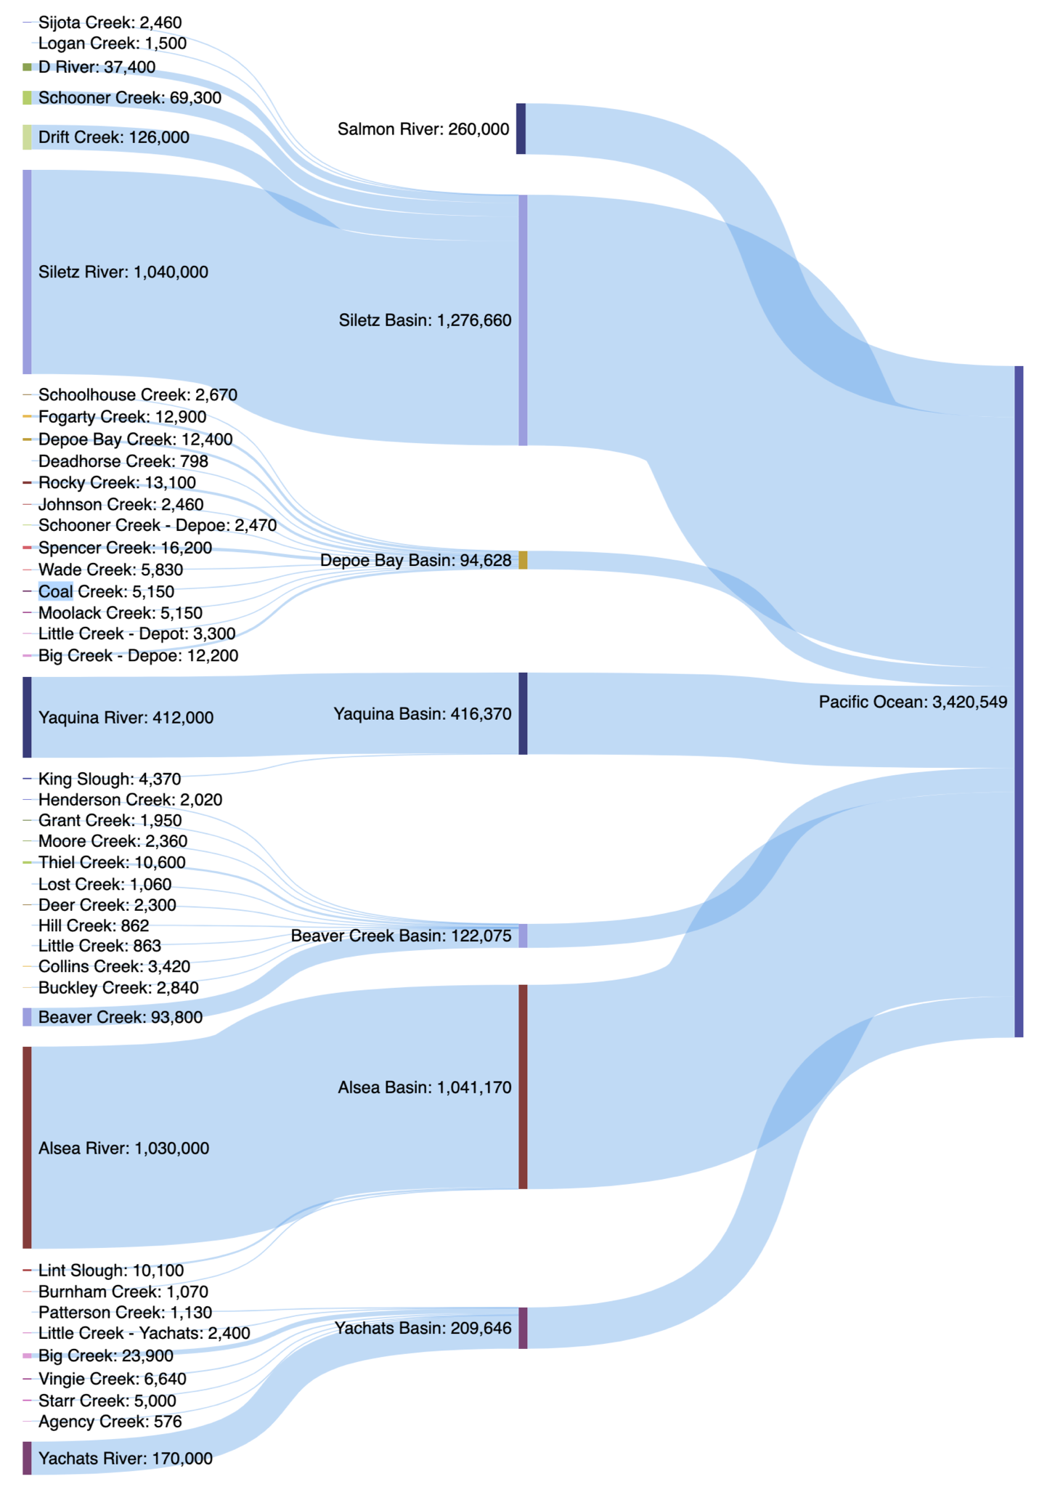
Figure 7. Volume of surface water in streams, rivers, and basins in the Mid-Coast.
Numerous state and federal statutes implement regulations affecting the management of water quality in Oregon. In addition, other programs with water quality regulations include the Groundwater Quality Protection Rules, Underground Injection Control Rules, NPDES and WPCF Permits Program Rules, Reclaimed Water Program Rules, Hazardous Waste Management Program, Underground Storage Tank Program, Municipal Solid Waste Program, the Oregon Groundwater Quality Protection Act of 1989, and ​Biosolids Program regulating biosolids through the Oregon Department of Environmental Quality.

Water Quality Monitoring
The Mid-Coast Watersheds Council, Siletz Watershed Council, and the Yaquina Watershed Council collaborate with the Lincoln County SWCD, which periodically conducts much of the water quality monitoring in the Mid-Coast. Also, the Alsea Watershed Study is a paired watershed study that studies the impacts of forest practices on water quality, aquatic habitat, and salmon.
The Oregon Department of Environmental Quality monitors and evaluates water quality via the Ambient Monitoring Network and Oregon Water Quality Index, watershed monitoring (TMDLs), toxics monitoring, biomonitoring, Oregon Beach Monitoring Program, Volunteer Water Quality Monitoring, Groundwater Monitoring, and National Aquatic Resource Surveys. Information about all of these programs can be found here. Water Quality Assessment Information from DEQ can be found here. And a collection of DEQ’s ambient water quality, watershed and groundwater monitoring project reports can be accessed here.

Water Quality Impaired Streams in the Mid-Coast
Oregon’s Section 303(d) lists water quality impaired streams (Table 1) that have been identified for not meeting water quality standards for a specific water quality parameter. TMDLs (or alternate pollution control plans) are required for all water quality-limited streams. TMDLs set specific criteria for pollutant amounts in stream reaches that are water quality limited.

Table 1. Locations with water quality limitations
Location | Limitation
Salmon River Drainage Area | 36.6 miles of water quality limited streams
Siletz River Drainage Area | 83.6 miles of water quality limited streams
Yaquina River Drainage Area | 121.4 miles of water quality limited streams
Beaver Creek-Ocean Tributaries | 24.8 miles of water quality limited streams
Alsea River Drainage Area | 214.9 miles of water quality limited streams
Yachats River Drainage Area | 28.5 miles of water quality limited streams
Beaches | 4

Groundwater Quality
Multiple water providers in the Mid-Coast use groundwater. Some of these water providers have water treatment systems, and others do not. According to the Oregon Department of Environmental Quality, statewide studies of groundwater during the past 20 years have found that nitrate is the most commonly detected groundwater contaminant, followed by pesticides, volatile organic compounds, and bacteria. Private, domestic wells are not required to conduct routine water quality testing or to treat contaminants. Oregon’s Domestic Well Safety Program partners with local health departments and water providers to promote domestic well safety and improve local and state capacity to assess and manage risks associated with private wells.

Ecology
The ecology in the Mid-Coast was summarized in a report (Appendix A) as part of Step 2 of the planning process and can be summarized as follows:
- The Mid-Coast supports a variety of habitats, with aquatic habitats being of particular interest because of their connection to human population water supply needs. Aquatic habitats include streams and springs, lakes, riparian areas, wetlands, and estuaries.
- The Oregon Conservation Strategy (OCS) identifies species of interest and areas of ecological importance in the different regions of the state. The Strategy identified 12 streams or estuary habitats as areas of ecological importance in the Mid-Coast because of the diverse habitats and species they support. For example, the Siletz Watershed has the only coastal origin population of summer Steelhead in Oregon.
- Aquatic species of interest in the Mid-Coast include seven species of salmon, Green and White sturgeon, beaver, and three species of Lamprey. The seven salmonids are: Coho, Chum, Fall chinook, Spring chinook, Winter Steelhead, Summer Steelhead, and Sea-run Cutthroat. Oregon Coast Coho Salmon is listed as threatened under the Endangered Species Act, and large portions of the Mid-Coast are designated as critical habitat for Coho. Green Sturgeon also is listed as threatened within the Southern Distinct Population Segment, which includes Yaquina Bay.
- Salmon are a keystone species in the Mid-Coast because of their influence on other plant and animal species. Salmon are an indicator species for habitat health because they require diverse quality habitats throughout their lifecycle that other species also require.
- Sources of habitat degradation include stream channel simplification and incision, warm stream temperatures, altered streamflow timing and watershed function, turbidity related to peak streamflow, and toxic and non-toxic pollutants.
- Aquatic habitat restoration efforts occur in the Mid-Coast to increase stream channel complexity, reduce fine sediment inputs and summer water temperature, address fish passage barriers, and encourage beaver dams, or similar structures.

Habitats in the Mid-Coast
Aquatic habitats include rivers, streams, springs, riparian areas (i.e., interface between water and land), estuaries, wetlands, and lakes. The shape of each river basin (how confined the river valley is, the type of bedrock geology, the gradient or slope of the stream, and the local climate) determines the types of streams that occur in a basin.
Good quality habitat in streams includes quality water—cool temperatures, high dissolved oxygen, and low turbidity. Temperature affects water chemistry and species survival. Healthy streams can maintain summer temperatures below levels that are unhealthy for the species of interest. Shade, groundwater and subsurface flow, and overall streamflow (i.e., water quantity) moderate temperature. Streams are more vulnerable to warming when riparian areas do not provide enough shade, most or all of the streamflow is on the surface (i.e., the stream is running over bedrock), and streamflow decreases. Temperature and dissolved oxygen concentration are linked, and both parameters are critical to the reproduction and survival of anadromous fish.
​Riparian habitats are the upland areas immediately adjacent to streams. Healthy riparian habitats have woody plants that stabilize banks, contribute large woody debris, contribute food supply for instream species, and provide shade that reduces stream temperature fluctuations.
​At the interface between freshwater and saltwater are estuary habitats, which support diverse plant and animal species. Estuary habitats provide an important freshwater-saltwater transition area for salmon. The Mid-Coast has two types of estuaries: (1) drowned river mouth estuaries are river valleys that flooded about 10,000 years ago from sea level rise; and (2) tidally restricted coastal creek estuaries are streams that discharge directly into the ocean and experience inputs of ocean water during high tides.
The main types of wetlands in the Mid-Coast are aquatic beds, marshes, peatlands, wet prairies, scrub swamps, and forested swamps.
The largest lakes in the Mid-Coast are Devil’s Lake (a natural lake located near Lincoln City), Valsetz Lake (formed by Valsetz Dam on the South Fork Siletz River) Olalla Reservoir (formed by Olalla Dam on Olalla Creek), and Newport Reservoir (formed by Big Creek Dam on Big Creek).

Species and Habitat Needs
The Mid-Coast has many species that spend at least part of their life cycle in water and are listed by state or federal agencies for protection or monitoring and/or identified by the Oregon Conservation Strategy (OCS) as a “species of interest.” Salmonids require large woody debris, deep pools, and spawning gravels. Factors negatively impacting salmonids are low water availability (particularly in late summer and fall), impaired water quality (e.g., warm stream temperatures), and fish passage barriers (e.g., undersized culverts). Green and White Sturgeon are also species of interest in the Mid-Coast. Sturgeon are especially sensitive to estuary conditions, where they congregate during summer and fall. Sturgeon spawn in freshwater several times during their adult life, thus adults and juveniles are also sensitive to freshwater conditions, including stream temperature and gravel conditions.
Several species of lamprey (Pacific, River, and Brook) are also species of interest and require many of the same habitat characteristics as salmonids.
Beavers are a species of interest because of their ability to build dams and create ponds that provide habitat for other wildlife, promote nutrient cycling, moderate flows, recharge the aquifer, and store water, among other benefits.
Other species of interest are invasive species, which are non-native species that have a disproportionate effect on the ecosystem that is typically negative, such as outcompeting and displacing native species and reducing species diversity.

Aquatic Habitats
Streams
Healthy stream habitats have cool temperatures, high dissolved oxygen, low turbidity, riparian vegetation, and stream channel complexity. Stream health benefits from watersheds that store precipitation in springs, wetlands, beaver ponds, and in the streambanks/floodplains. In healthy streams, streamflow often overtops streambanks during flood events. When this occurs, floodwaters are slowed by streamside vegetation, providing refuge for aquatic species from high flows. Finer sediments, larger cobble, and boulders suspended in floodwaters are deposited in floodplains and store water that is later released into the stream channel. Stream health also benefits from a diversity of disturbances in the watershed, such as fire, debris slides, windstorms, and floods that increase habitat diversity. Floods move large substrate and large woody debris from upper reaches and tributaries to lower reaches within the watershed.
Stream temperature affects water chemistry and species survival. Shade, cool groundwater discharges into the stream, and water quantity moderate stream temperatures. Temperature and dissolved oxygen concentration are linked, and both parameters are critical to the reproduction and survival of anadromous fish. Stream temperature affects biological triggers for salmon migration, spawning, and egg hatching. High stream temperatures and low dissolved oxygen as well as high turbidity can threaten fish survival at various life stages.
Riparian Habitats
Riparian habitat is at the interface between land and a river or stream. Plant and animal species may use all riparian habitats, or may specialize on a particular geomorphic surface within the riparian area. Rivers are constantly changing, eroding surfaces, and depositing material to create new surfaces. Similarly, vegetation communities in riparian areas change as they become inundated by flood waters, dried out because of a shift in the direction of streamflow, or fall into the stream channel from bank erosion. Upland and riparian habitat influences instream health, and upstream health influences downstream characteristics.
Estuary Habitats
Estuaries provide a transition zone between freshwater and saltwater, and contain unique habitats that support a diversity of plants and animals adapted to a balance of saltwater and freshwater. Estuaries also serve to filter pollutants, stabilize shorelines, and buffer communities from storm surges. Estuaries are especially important for salmon during key points in their lifecycle. Estuary habitats are influenced by watershed size, geology, ocean tides, and freshwater-saltwater mixing. Although estuaries are dynamic systems that change with high tide and low tide, they are also sensitive to changes. Plant and animal communities in each estuary are adapted to a specific range of salinity. Changes to sea level, ocean currents, or freshwater inputs from streamflow can alter the balance of saltwater and freshwater and sediment dynamics, impacting plant and animal communities.
For more information about different types of estuaries, click here and here. The Coastal Atlas Estuary Data Viewer can be accessed here. For more information about individual estuary management plans, click here.
Mid-Coast estuaries, with the exception of the Depoe Bay Estuary (which is small), are moderate in size and have large areas of salt marsh, eelgrass, and tidal flat habitat.
Salmon River Estuary. This is classified as a Natural Estuary and has little residential, commercial, and industrial development. The entire estuary and its associated wetlands are part of the Cascade Head Experimental Forest and Scenic Research Area, which is owned and managed by USFS. The entire Cascade Head area is 11,890 acres; the estuary comprises 205 acres.
Areas of Ecological Importance and Critical Habitat Designations: Habitat areas include wetlands, mudflats, emergent herbaceous wetlands, and intertidal marsh. The estuary provides transitional habitat between freshwater and saltwater for upstream spawning migrations for anadromous fish and rearing areas for juveniles and smolts. The Salmon River Estuary is part of the Salmon River Estuary-Cascade Head Conservation Opportunity Area.
Species of Interest: The Salmon River Estuary was nominated as an Important Bird Area for brown pelican, bald eagle, and peregrine falcon, and for its abundance of shorebirds, including western sandpipers.
Siletz Bay Estuary. Siletz Bay is classified as a Conservation Estuary. It lacks jetties or channels, but is near Lincoln City, which has altered some of the shoreline near the estuary. USFWS manages a 568-acre portion of the bay as a national wildlife refuge, which includes coastal conifer and hardwood forest, estuarine tidelands, and freshwater riparian habitats. The estuary was formerly diked to drain land for raising dairy cows. USFWS is managing the refuge to allow the salt marsh to return to its natural state, where tides inundate the refuge twice daily. The Siletz Bay is a Conservation Opportunity Area.
Species of Interest: The Siletz Bay Wildlife Refuge provides nursery habitat for Coho and Chinook Salmon, Steelhead and Cutthroat Trout, and other anadromous species. Spring Chinook usually arrive to the refuge in May, and American shad arrive between late April to the end of May. The refuge is also home to red-tailed hawks, bald eagles, barn owls, red-shouldered hawks, ospreys, turkey vultures, merlins, and peregrine falcons as well as estuary-dependent birds, including great blue herons, great egrets, Virginia rails, eared grebes, brown pelicans, buffleheads, common mergansers, wood ducks, northern shovelers, American wigeon, green-winged teals, and double-crested cormorants. Mammals at the refuge include Roosevelt elk, black-tailed deer, harbor seals, mink, river otter, muskrat, and beaver. Siletz Bay has native, common eelgrass as well as exotic Zostera japonica, which was introduced with non-native oysters.
Depoe Bay Estuary. Depoe Bay estuary is about 25 acres. The estuary is landlocked, with the exception of the harbor entrance, which was developed to support fishing, tourism, lumber, and agriculture. The bay supports bald eagle nesting sites and black oystercatchers, among other species. Depoe Bay is a Conservation Opportunity Area.
Yaquina Bay Estuary. Yaquina Bay is a 4,300-acre estuary located in the City of Newport. It is classified as a Development Estuary. Current uses of Yaquina Bay include fishing and fish processing, logging, shipping, tourism, aquaculture, and agriculture. The estuary has been dredged and filled at several locations to support these uses and to allow for development. Oregon State Parks owns the Yaquina Bay State Recreation Site, a 32-acre parcel of land overlooking the mouth of Yaquina Bay. There are large, cultivated shellfish operations in the Yaquina estuary.
Areas of Ecological Importance and Critical Habitat Designations: Yaquina Bay is listed as critical habitat for Green Sturgeon. Yaquina Bay State Recreation site is a spruce and pine forested bluff. Lower Yaquina Bay has little freshwater influence and is popular for shellfish harvesting. The Wetlands Conservancy has identified high salt marsh, tidal Sitka spruce swamp, and non-tidal Sitka spruce swamp as the highest priorities for habitat restoration. The estuary also has eelgrass beds, and nesting eagles and osprey. Spruce swamps are located in the upper estuary along Elk Creek and Little Elk Creek and areas for potential restoration of high salt marsh are located in Boone Slough and Nute Slough. Currently, there is an eelgrass mitigation project in the eastern portion of Marina Bed. Yaquina Bay is a Conservation Opportunity Area.
Alsea Bay Estuary. Alsea Bay is designated as a Conservation Estuary, is one of only four estuaries in Oregon that is managed for conservation under the CZMA, and does not have jetties at the ocean entrance. Recreational fishing and clamming are allowed in Alsea Bay and species present include cockles and purple varnish clams, softshell clams, and Dungeness crabs. There are two public boat launches at Alsea Bay, including the Port of Alsea boat launch and McKinley’s Marina.
Species of Interest: Alsea Bay supports Green Sturgeon as well as a diversity of other species.
Areas of Ecological Importance and Critical Habitat Designations: The east side of Alsea Bay has more than 400 acres of undisturbed marsh habitat and additional marsh habitat in the lower reaches of Drift Creek, a FEMAT-designated key watershed. Additional tidal high marsh habitat that is recovering from previous grazing disturbance is found west of Barclay Meadows and east of Eckman Lake. The Bayview Oxbow has about 150 acres of diked former tidal marsh. Barclay meadows contains small areas of diked former tidal marsh. Bain Slough is a forested wetland located at River Mile 9 that has well-developed remnant tidal channels. A tidegate, ditching, and residential development all reduce tidal influences at Bain Slough, which was likely a spruce tidal swamp at one time. Alsea Bay has been identified as a Conservation Opportunity Area.
Yachats River Estuary. Yachats River Estuary is about 40 acres and is classified as a Conservation Estuary. The Yachats River Estuary is part of the Yachats River Area Conservation Opportunity Area. It is a designated Important Bird Area of Oregon and includes marbled murrelet and spotted owl nesting sites.

Wetland Habitats
Wetlands are areas where water covers the soil, or is present either at or near the surface of the soil all year or for varying periods during the year, including during the growing season. Wetlands can be influenced by local geologic conditions that provide the parent material for soils, influence groundwater chemistry, and affect wetland vegetation. Wetlands in the Mid-Coast have either organic soils (muck, mucky peats, fibrous peats, or combinations of these) that are saturated perennially or mineral soils (sand, silt, and silty loams, sandy loams, or clay loams) that may be flooded in the winter and moist or dry in the summer. The main types of wetlands in the Mid-Coast, each with unique soils and vegetation communities, are aquatic beds, marshes, peatlands, wet prairies, shrub swamps, and forested swamps.

Mid-Coast Areas of Ecological Importance
ODFW established the Oregon Conservation Strategy (OCS), which identifies areas of ecological importance, or Conservation Opportunity Areas, where broad fish and wildlife conservation goals would best me met. The areas of ecological importance in the Mid-Coast, including the important habitat that exists in each location (Table 2).
Table 2. Areas of ecological importance
Location | Important habitat
Alsea Estuary-Alsea River | Overwintering habitat for migrating waterfowl and rearing habitat for coastal salmonid
Beaver Creek | Diverse habitat from beach to old-growth forests
Depoe Bay Area | Productive rocky shore for fish and wildlife use
Devil’s Lake | Peat marsh near mouth of Rock Creek, an important coho rearing stream
Salmon River Estuary-Cascade Head | Diverse habitats; includes Cascade Head Scenic Research Area; Habitat for three threatened and endangered species
Siletz Bay | Siletz estuary provides diverse and complex habitat
Siletz River | Sandstone/basalt river system with flashy winter river flow and private forestland
Yachats River Area | Narrow river channel with wide shallow mouth at ocean; steep coastal mountains
Yaquina Bay | Eelgrass beds, intertidal and subtidal shellfish beds, native oyster beds, and nesting eagles and ospreys along estuary

Habitat Degradation
The main threats to aquatic habitats in the Mid-Coast include reduction in stream complexity, barriers to fish passage, reduced water quality, and reduced water quantity or alterations in streamflow. Specific factors influencing regional habitat quality and decline of salmon include ocean conditions, land use practices, landslides, fish hatcheries, and major flood events. Human-induced factors, such as habitat degradation, water diversions, land use practices, and artificial propagation, have contributed to the decline of coho salmon. Reduced amount and complexity of habitat, degraded water quality, blocked/impaired fish passage, and uncertainty that there is an adequate combination of voluntary and regulatory mechanisms to ensure success are limiting factors. Salmon populations in streams with water quantity or water quality limitations, or simplified stream channels, may be more susceptible to further habitat degradations that result in additional stress.
​Habitat degradation in aquatic habitats include stream channel simplification and incision, warm stream temperatures, altered streamflow timing and watershed function, excess turbidity at periods of peak streamflow, and impairments or barriers to fish passage. Stream channel simplification and incision can arise from removing riparian vegetation, removing large woody debris from streams, and channelizing streams. Historical land use practices are the source of stream channel simplification and incision in many areas. Warm temperatures can occur from lack of riparian vegetation, reduced streamflow, and stream channel simplification. Altered streamflow timing can result from land management practices and streamflow withdrawals, both of which affect how water moves through the landscape (i.e., watershed function). Land management practices can affect the rate at which fine sediments from the landscape are transported to streams and also can affect the magnitude of peak flows, which may combine to increase turbidity to levels that negatively affect wildlife and impair or prohibit water treatment for human consumption.
Habitat restoration projects are occurring throughout the Mid-Coast to improve habitat conditions and reduce further degradation. These projects include adding large woody debris into streams, increasing fish rearing areas off the main channel’s streams, supporting gravel substrate used for spawning and deep pools, increasing streamflow during key times of the year for fish species and in the summer to reduce settling of fine sediment inputs, maintaining riparian vegetation for shading and filtering, and lower water temperatures, improving roads to reduce sediment inputs, and encouraging beaver dam formation.
Appendix B provides information on key locations and issues within each of the eight drainage basins in the Mid-Coast region.

Action Plan Overview

Action Plan Development
The development of the action plan was guided by key water issues and drivers.

Key Water Issues
During Step 3 of the planning process, the Partnership identified a total of 18 key issues in eight categories for which consensus had been achieved:
Water Conservation
- The Mid-Coast needs a coordinated water conservation initiative/strategy that focuses on reducing water use, educating stakeholders, promoting incentives, and effectively using limited water supplies, especially in times of water shortage.
- Rural residents and businesses need improved access to information, incentives, funding, and resources to help them implement water conservation measures.
Natural Hazards, Vulnerabilities, and Emergency Preparedness
- The majority of water providers need redundancy, water system interconnections, and alternative sources to ensure access to safe drinking water in case of emergencies or shortages.
Climate Change Impacts
- Climate change is having profound impacts on the ecosystem, which affects the health and well-being of coastal communities. Although we may not fully understand nor be able to accurately predict climate change effects, we can and should proactively adapt to climate change impacts at a regional scale.
Local Capacity and Regional Collaboration
- Mid-Coast water providers share the need for system resilience and reliable source water quantity and quality. Regular coordination and collaboration among water providers can improve access to resources and funding to support this need.
Water Quantity for Instream and Out-of-Stream Uses
- Summer streamflows are insufficient in some areas of the Mid-Coast to meet the instream water needs of fish and wildlife. Low streamflows contribute to water quality impairments (e.g., high temperatures) that negatively affect fish and wildlife.
- Many streams in the Mid-Coast lack: 1) legal protections (e.g., instream water rights) to protect streamflows for the full range of ecological flows, and 2) streamflow targets to guide instream flow restoration efforts where there are already significant out-of-stream uses.
- Some municipal and special district water providers are currently facing water shortages late in the summer and during dry years.
- Rural residents and landowners, agricultural irrigators, and industrial water users currently experience chronic seasonal water scarcity due to limited water availability.
- Some watershed systems, such as the Siletz, have insufficient water to meet the needs of all uses (both instream and out-of-stream) leading to ecological impacts on the rivers, insecurity for water users, and the potential for conflict.​
Watershed Health
- Opportunities exist in the Mid-Coast for enhancing beaver habitat and management to improve water storage, stream health, and support the recovery of key native fish species.
- Degraded riparian areas throughout the Mid-Coast negatively affect water quality, wildlife habitat, and overall watershed health. Opportunities exists to improve these areas.
Water Quality for Instream and Out-of-Stream Uses
- Multiple river and stream segments consistently do not meet Oregon and federal water quality standards: high temperature and low dissolved oxygen threaten fish, and elevated turbidity affects the ability to treat and use water.
- Low stream flow and high temperatures in the summer months, and high turbidity due to winter storms, pose challenges for drinking water suppliers to meet state and federal regulations to provide safe drinking water.
- Self-supplied rural residents are increasingly concerned about drinking water quality and need adequate and timely data to determine regional, local, or site-specific water quality contamination issues that may pose a health risk.
Infrastructure
- The degradation of aging water infrastructure used to divert, store, treat, and convey water can lead to water loss and water quality issues, and poses a threat to the health and safety of communities.
- Infrastructure to manage water for self-supplied uses (rural residences and agricultural operations) is oftentimes undocumented, old, inefficient, and fails to meet current construction and quality standards, which negatively affects water security and source water quality throughout the region.
Key drivers in the Mid-Coast
Indirect drivers
Demographic. There is an increasing number of residents and visitors in the Mid-Coast region causing higher water demands, especially during the summer months when peak demand for water coincides with the period of lowest water availability
Economic. There is a need for adequate water supplies to support local industries which are key economic engines in the Mid-Coast region, such as commercial fishing, seafood processing, forest products, recreation, and tourism.
Sociopolitical. Mid-Coast residents express a desire for more sustainable and equitable approaches to managing and using water—providing adequate water quantity and quality for ecosystem services (e.g., native salmon and trout populations, recreation), economic growth (e.g., supporting local industries) and community health (e.g., rural residents, limited income, and vulnerable populations).
Direct drivers
Climate variability and change. Climate change stressors include increased periods of drought, reduced summer stream flows, warmer stream temperatures, lower dissolved oxygen in water bodies, and increased winter flooding, sediment supply and turbidity, all of which affect water quality and quantity in the Mid-Coast.
Nutrient and chemical inputs. Excess nutrients, such as phosphorus and nitrogen, can contribute to water quality impairments in streams, lakes, and estuaries, such as algal blooms, low dissolved oxygen, increased chlorophyll, and changes in pH (Borok 2014).
Land conversion. Urban expansion and development can place significant demands on ecosystem services and alter the quality of those services. Converting forest lands to other uses can impact the amount of water captured in soils and water bodies and available for ecosystem and human uses.
Biological invasions and diseases. Invasive species and other biological invasions create monocultures and outcompete natives affecting aquatic, terrestrial and/or human health (e.g., Japanese knotweed in riparian zones, elodea in lakes).
- Multiple sources of funding are needed to address current and legacy infrastructure issues and to design and build resilient infrastructure that can withstand natural hazards and help communities adapt to climate change.

Drivers
Drivers are any natural or human-induced factor that directly, or indirectly, cause a change in an ecosystem (Carpenter et al. 2006), and that interact across spatial, temporal, and organizational scales to effect ecosystem change in a region, or a specific location (Nelson et al. 2006). Insufficient stream flows, reduced water quality, degraded riparian areas, and warmer stream temperatures are examples of states, or conditions, that exist in the Mid-Coast region of Oregon as a result of a suite of drivers that interact to create these conditions. Understanding the drivers that influence ecosystem change and status, assessing conditions to articulate the current status, or condition, and articulating clear objectives supported by specific actions that improve conditions to desired states, is critical to successful plan implementation. Key drivers and be indirect and direct (Nelson et al. 2006).

Overview of the Strategic Action Imperatives
Five, action-oriented imperatives were created to organize and synthesize the key watershed issues stakeholders described during the planning process. In addition, two themes—Public Awareness and Support, and Monitoring and Data Sharing—emphasize needed actions to advance public acceptance and support of water initiatives and the means to obtain data and information on water quality and quantity to inform regional decision making.
Regional Capacity and Collaboration. Regional collaboration among water providers enhances the resilience of the water delivery system and helps ensure reliable source water quality and quantity. Strategies to enhance regional collaboration may include pooling regional resources, providing technical information to landowners, and improving access to resources and funding.
Resilient Water Infrastructure. Sustaining the collection and distribution systems, treatment plants, and other infrastructure that collects, treats, and delivers water requires strategies that address aging infrastructure, support a more resilient infrastructure, and advance training and professional development to ensure the availability of skilled water technicians.
Water Conservation, Efficiency, and Reuse. Water conservation is the beneficial reduction in water loss, waste or use, and results in people changing behavior and thus using less water. Water efficiency minimizes the amount of water used to accomplish a function, task, or result, and relies on well-engineering products and fixtures (Source: Water Footprint Calculator). Indoor water conservation actions may include turning off running water while brushing teeth and operating washing machines and dishwashers only when loads are full. Outdoor water conservation actions may include watering lawns only when necessary, watering lawns during the cool part of the day, mulching trees, and installing a rain barrel for outdoor watering. Examples of water efficient actions include using low-flow showerheads and toilets. Due to limited water availability for new out-of-stream uses across the Mid-Coast region as well as the need to restore and protect instream values, water conservation may be one of the most cost-effective ways to meet future water needs of the region while increasing water security and resiliency for all users.
Source Water Protection and Water Supply Development. Source water includes the rivers, streams, lakes, reservoirs, springs, and groundwater that deliver water to public drinking water supplies and private wells. Protecting source water reduces treatment costs, protects water quality for wildlife and human uses, and helps ensure the availability of water. Strategies to protect source water depend on the source, and include protection of riparian habitats, stream bank stabilization, land protection/easements, best management practices for agricultural and forestry activities, local ordinances to limit activities in source water or wellhead protection areas, emergency response plans, and outreach and education. Source: Environmental Protection Agency.
Ecosystem Protection and Enhancement. Ensuring the health of ecosystems through protection and enhancement actions helps the sustainable delivery of ecosystem services, including adequate water quality and quantity, reduced drinking water treatment and infrastructure costs, reduced flood mitigation costs, increased resilience to climate change stressors, opportunities to recover listed species and provide habitat for native fish and wildlife, and reduced risk for invasive species introductions and establishment.

Performance Metrics
Developing performance metrics, or indicators, to assess progress made implementing any plan is critical to success. The first key step in the development of metrics is establishing criteria used to inform the metrics. Relevance to management goals and objectives, sensitivity to stressors, high “signal-to-noise” ratios (i.e., significant changes to an indicator are caused by changes in stressors versus stochastic variability), quantifiability, accuracy, precision, ability to monitor, cost-effectiveness of monitoring, and measurements that can be interpreted unambiguously, are key criteria that have been used to indicate watershed health (City of Portland Bureau of Environmental Services 2019), and could arguably be foundational to all of the imperatives and their associated actions in this plan.

Implementing the Water Action Plan
The next portion of the Mid-Coast Water Planning Partnership Water Action Plan includes an implementation table that describes a suite of actions to achieve the water objectives and priorities in the Mid-Coast region of Oregon during the next 10 years, from 2022–2032. The implementation plan, similar to all other aspects of this plan, is intended to serve as a living document, and to be updated on a regular basis to address emerging issues, to ensure its relevance, and to incorporate adaptive management principles.
It is anticipated that each of the entities involved in the development of this plan and actions can identify the role they may play in implementing one or more of the actions in the table, and that all will continue to work collaboratively to assess progress made implementing the actions.

Imperative 1. Public Awareness and Support
Public awareness of water issues in the Mid-Coast region of Oregon is critical to achieving the long-term goals the region has for delivering water sustainably for people and native fish and wildlife.

Objectives
- Assess the levels and presence/absence of contaminants in Mid-Coast waters and describe negative effects to human health.
- Sample throughout the Mid-Coast to accurately identify the quantity and type of toxics entering source waters to assess potential risks to both drinking water quality and aquatic life.
- Provide self-supplied water users with adequate and timely data to determine regional, local, or site-specific water quality contamination issues that may pose a health risk.
- Promote tools and information for water conservation.
- Foster a culture of water conservation.
- Build capacity of constituents to advocate for state and federal resources and funding.
- Support training and professional development to ensure the availability of skilled water technicians.

Action Details
Action |  | Desired Outcomes | Lead & Participants | Timeline | Budget | Potential Funding Sources
1. | Develop and implement a public awareness and engagement campaign aimed at supporting the imperatives and actions in the Mid-Coast Water Action Plan, including raising awareness and understanding of regional water issues. Include the following: | Residents and industries in, and visitors to, the Mid-Coast region are aware and proud of, and practicing a culture of water conservation. Public and private water suppliers are participating in water management and conservation planning and outreach to communities. Uniform region-wide messaging about water use and conservation. | Lead: Education (all levels), interpretive facilities (Oregon Coast Aquarium, Hatfield Marine Science Center), regional water providers (private and public), Oregon Water Resources Department, Oregon State University Extension Services  Participants: Water use industries, tourism industry, water rights holders | PHASES 1-2 | $250,000 | - Oregon Health Authority Drinking Water Source Protection Grants & Loans.  - Oregon Community Foundation's Oregon Natural Resources Education Fund.  - Autzen Foundation.  - OWEB Partnership Technical Assistance Grant. Georgia-Pacific Environment Grant Program.  - U.S. Economic Development Administration (EDA).  - EPA's Environmental Education (EE) Grants.  - Siletz Tribal Charitable Contribution Fund.  - Spirit Mountain Community Fund.  - Starker Forests Grant.  - Three Rivers Foundation.
 | Conservation:  a. Promote water conservation at local events, on the Mid-Coast Water Planning Partnership website and the websites of regional partners and entities, in news articles, in water bills, via social media, and through outreach materials to businesses, particularly in the hospitality industry.  b. Develop drought declaration and audience-specific (e.g., self-supplied industrial water users) water conservation and curtailment messages. | a and b. Messaging associated with drought and water curtailment, which is consistent as practicable across the Mid-Coast, is developed and distributed. | Lead: Mid-Coast water providers (e.g., Mid-Coast Water Conservation Consortium), Lincoln County Board of Commissioners | PHASE 1 | $40,000 | a)  - Georgia-Pacific Environment Grant Program.  - Business Oregon Drinking Water Source Protection Fund.  - U.S. Economic Development Administration (EDA).  - EPA's Environmental Education (EE) Grants.  - Spirit Mountain Community Fund.  - Starker Forests Grant.  - Three Rivers Foundation.  b)  - OWEB Partnership Technical Assistance Grant.  - Business Oregon Drinking Water Source Protection Fund.  - U.S. Economic Development Administration (EDA).
 | Regional Collaboration:  c. Coordinate watershed and water system tours to increase awareness and understanding of regional and local water issues. | c. Increased understanding of regional and local water issues. | Lead: Mid-Coast Water Planning Partnership | PHASES 1-3 |  | - Meyer Memorial Trust Grant.  - OWEB Partnership Technical Assistance Grant.  - Georgia-Pacific Environment Grant Program.  - Business Oregon Drinking Water Source Protection Fund.  - National Communication Association Advancing the Discipline Grants.  - EPA's Environmental Education (EE) Grants.  - NFWF Five Star and Urban Waters Restoration Grant Program (Watershed only).  - U.S. Department of Housing and Urban Development Sustainable Communities Regional Planning Grant.  - Gray Family Foundation Environmental Education Grant.  - Siletz Tribal Charitable Contribution Fund.  - Spirit Mountain Community Fund.  - Starker Forests Grant.  - Three Rivers Foundation.
 | Infrastructure:  d. Develop a regional initiative/training to improve coordination and provide education to water providers on infrastructure financing and funding. | d. Water providers receive information on infrastructure financing and funding. | Lead: Water providers, Mid-Coast Water Conservation Consortium, Fund Managers | PHASE 1 | $50,000 | - Meyer Memorial Trust  - Oregon Community Credit Union (OCCU) Foundation.  - Georgia-Pacific Environment Grant Program.  - National Communication Association Advancing the Discipline Grants.  - U.S. Economic Development Administration (EDA).  - U.S. Department of Housing and Urban Development Sustainable Communities Regional Planning Grant.  - Siletz Tribal Charitable Contribution Fund.  - Spirit Mountain Community Fund.  - Starker Forests Grant. Three Rivers Foundation.
 | Education:  e. Provide an internship program, hands-on training, and certification training for water technicians. | e. Each water provider has an updated water management and conservation plan they are implementing. | Lead: Water providers, Oregon Coast Community College (OCCC) | PHASE 2 | $250,000 | - Meyer Memorial Trust  - Oregon Community Credit Union (OCCU) Foundation.  - Georgia-Pacific Environment Grant Program.  - National Communication Association Advancing the Discipline Grants.  - U.S. Economic Development Administration (EDA).  - U.S. Department of Housing and Urban Development Sustainable Communities Regional Planning Grant.  - Siletz Tribal Charitable Contribution Fund.  - Spirit Mountain Community Fund.  - Starker Forests Grant.  - Three Rivers Foundation.
 | f. Identify or develop curriculum and materials/information for students and the public (community education) about their water sources, water management, and water conservation. | f. Students are learning about their water supply and the importance of water conservation, and they share that information with family members. | Lead: Mid-Coast Water Conservation Consortium, Lincoln County School District education (all levels), interpretive facilities (Oregon Coast Aquarium, Hatfield Marine Science Center), water providers, Oregon Water Resources Department, Oregon Coast Community College Community Education, Lincoln County Department of Health  Participants: Educators and students, Lincoln County schools | PHASE 2 | $75,000 | - OWEB Partnership Technical Assistance Grant.  - Georgia-Pacific Environment Grant Program.  - National Communication Association Advancing the Discipline Grants.  - EPA's Environmental Education (EE) Grants.  - Gray Family Foundation Environmental Education Grant.  - Siletz Tribal Charitable Contribution Fund.  - Spirit Mountain Community Fund.  - Starker Forests Grant.  - Three Rivers Foundation.
 | Voluntary actions:  g. Conduct outreach on the implementation of voluntary, incentive-based actions throughout the region, consistent with existing plans, such as the Mid-Coast Agricultural Water Quality Management Area Plan. | g. Voluntary, incentive-based actions effectively help to deliver on the goals on regional plans, including the Mid-Coast Agricultural Water Quality Management Area Plan. | Lead: All water users | PHASES 1-3 |  | - EPA's Environmental Education (EE) Grants.
 | Source Water Protection and Development:  h. Inform self-supplied water users with water quality information from source waters and water protection measures, including proper well construction and maintenance. Provide outreach/education on septic system management to protection groundwater and surface water. | h. Self-supplied water users can access available water quality information concerning source water, implement measures to reduce impacts on source water quality, conduct regular inspection, maintenance, and repairs (as needed) of septic systems, and understand how to access and use available water quality data. | Lead: Oregon Health Authority, Oregon State University Extension, County, Oregon Department of Environmental Quality, water providers | PHASES 1-3 |  | - OWEB Partnership Technical Assistance Grant.  - Business Oregon Drinking Water Source Protection Fund.  - U.S. Economic Development Administration (EDA).  - EPA's Environmental Education (EE) Grants.  - Siletz Tribal Charitable Contribution Fund.  - Spirit Mountain Community Fund.  - Starker Forests Grant.  - Three Rivers Foundation.
 | i. Work with partners and agencies (e.g., Oregon State University Extension) to deliver information on safe pesticide application practices and vegetation management practices that reduce or eliminate pesticide use. Provide outreach on water quality impacts of pesticides and fertilizers associated with lawn management near streams and ponds. Share methods that reduce impacts and identify alternatives. | i. Pesticides are applied minimally and safely throughout the region. Options are developed that reduce impacts and provide alternatives to pesticides. | Lead: Oregon Department of Agriculture, Oregon Health Authority | PHASES 1-3 |  | - OWEB Partnership Technical Assistance Grant.  - Georgia-Pacific Environment Grant Program.  - Business Oregon Drinking Water Source Protection Fund.  - U.S. Economic Development Administration (EDA).  - EPA's Environmental Education (EE) Grants.  - Siletz Tribal Charitable Contribution Fund.  - Spirit Mountain Community Fund.  - Starker Forests Grant.  - Three Rivers Foundation.
 | j. Conduct education in source water areas (including to those that may not be customers of the water provider) about drinking water sources, risks, choices, and strategies. | j. The public is aware of and supports source water protection measures. | Lead: Education (all levels), interpretive facilities (Oregon Coast Aquarium, Hatfield Marine Science Center), regional water providers (private and public), Oregon Water Resources Department, Oregon State University Extension Services | PHASES 1-3 |  | - OWEB Partnership Technical Assistance Grant.  - Georgia-Pacific Environment Grant Program.  - Business Oregon Drinking Water Source Protection Fund.  - National Communication Association Advancing the Discipline Grants.  - U.S. Economic Development Administration (EDA).  - EPA's Environmental Education (EE) Grants.  - NFWF Five Star and Urban Waters Restoration Grant Program.  - Siletz Tribal Charitable Contribution Fund.  - Spirit Mountain Community Fund.  - Starker Forests Grant.  - Three Rivers Foundation.
 | k. Connect private landowners with resources and information about best management practices to improve water quality and quantity. | k. Landowners are connected with resources and information about BMPs to improve water quality and quantity. | Lead: Local stewardship foresters, local Soil and Water Conservation District staff, and USDA Natural Resources Conservation Service, Oregon State University Extension Services, Oregon Department of Forestry | PHASE 1 |  | - OWEB Partnership Technical Assistance Grant.  - Business Oregon Drinking Water Source Protection Fund.  - National Communication Association Advancing the Discipline Grants.  - EPA's Environmental Education (EE) Grants.  - Siletz Tribal Charitable Contribution Fund.  - Spirit Mountain Community Fund.  - Starker Forests Grant.  Three Rivers Foundation.

Performance Metrics
- Annual increase in engagement with residents, visitors, and industry about water resources.
- Residents, visitors, and industries are aware of and are practicing a culture of water conservation.
- Public and private water suppliers are participating in water outreach to communities.
- There is uniform region-wide messaging about water use and conservation.

Metric Methodology
- Baseline data is determined conducting an assessment to assess 1) existing outreach and engagement with the public on water-related issues 2) the effort of water suppliers to engage in outreach with the public, and 3) the uniformity of messaging about water use and conservation. A follow-up assessment is conducted 3-5 years later to determine increase in public engagement efforts and uniformity of messaging.
- Baseline data is determined by conducting a social survey with members of the public to assess their awareness and practices relative to water conservation.

Imperative 2. Regional Capacity and Collaboration
Regional collaboration among water providers enhances the resilience of the water delivery system and helps ensure reliable source water quality and quantity. Strategies to enhance regional collaboration may include pooling regional resources, providing technical information to landowners, and improving access to resources and funding.

Objectives
- Cultivate active coordination and collaboration among all regional water providers to improve access to resources and funding that enhance system resilience and reliable source water quantity and quality.
- Expand water conservation planning programs and initiatives.

Action Details
Action |  | Desired Outcomes | Lead & Participants | Timeline | Budget | Potential Funding Sources
2 | Regional Collaboration: Support the creation of a feasible 50-year county-wide water supply plan. | Conduct an updated analysis of supply and demand (use OSU Study) coupled with an alternatives analysis of potential strategies to reduce demand and/or increase supply (conservation, pricing, storage, reuse, new sources, etc.). | Lead: Lincoln County, Regional Solutions, Lincoln County Water Systems Alliance (LCWSA)  Participants: All Lincoln County water suppliers, regional stakeholders, OWRD and other state agencies) | PHASES 1-3 | $200,000
3 | Regional Collaboration: Support the development of organizational procedures for the Mid-Coast Water Conservation Consortium (MCWCC) and the Lincoln County Water Systems Alliance (LCWSA) that will facilitate the prioritization and funding of projects throughout the region. | The Mid-Coast Water Conservation Consortium and the Lincoln County Water Systems Alliance are structured to prioritize and fund water projects in the region. Explore organizational options for Mid-Coast Water Conservation Consortium that would enable entity to prioritize and fund projects throughout the region on behalf of members. | Lead: Mid-Coast Water Conservation Consortium, Lincoln County Water Systems Alliance  Participants: Independent, governmental, and industrial water suppliers and users | PHASE 2 |  | - Meyer Memorial Trust Capacity Building Grant.  - OWEB Partnership Technical Assistance Grant.  - Business Oregon Drinking Water Source Protection Fund.  - Special Public Works Fund (SPWF).  - U.S. Economic Development Administration (EDA).
4 | Regional Collaboration: Strengthen/support the Mid-Coast Water Conservation Consortium to enhance water conservation, increase resiliency during shortages and emergencies, and pool resources of multiple water providers. Support enhanced coordination with state and federal entities outside of the Mid-Coast. | Water suppliers have a strengthened ability to address water conservation issues, increase resiliency, and pool resources. | Lead: Mid-Coast Water Conservation Consortium, Lincoln County Water Systems Alliance  Participants: Water providers | PHASE 1 |  | - OWEB Partnership Technical Assistance Grant.  - Georgia-Pacific Environment Grant Program.  - Business Oregon Drinking Water Source Protection Fund.  - U.S. Economic Development Administration (EDA).
5 | Regional Collaboration: Support and advocate for a) planning and development that minimizes impacts to floodplains and riparian areas, promoting Green Infrastructure Methods (GIM) and Low Impact Development (LID) practices. | Natural storage (e.g., beaver protection) is supported, and open zoning regulations that promote marshland migration are encouraged. Planning and development minimize impacts to floodplains and riparian areas through the implementation of GIM and LID practices. | Lead: County planners, Department of Land and Conservation Development, municipal planning departments  Participants: US Forest Service, Oregon Department of Environmental Quality, Oregon Department of Fish and Wildlife, Oregon Department of Forestry | PHASES 1-2 |  | - Bureau of Reclamation Cooperative Watershed Management Grant (Phase I).  - OWEB Partnership Technical Assistance Grant.
6 | Conservation: Develop and update water management and conservation plans for the Mid-Coast regional municipal and self-supplied direct water systems. | Each water provider on the Mid-Coast has a recently updated water management and conservation plan appropriate in scale for the size of their customer accounts and demand. | Lead: Water providers and water users, all municipalities | PHASE 2 | $100,000 | - Business Oregon Drinking Water Source Protection Fund.
7 | Conservation: Coordinate water curtailment plans for water providers. | Water providers coordinate water curtailment plans and messaging to the extent practicable, particularly those sharing water systems and sources. | Lead: Entities with shared water systems/sources, Mid-Coast Water Conservation Consortium  Participants: Oregon Water Resources Department | PHASES 1-2 | $15,000 | - OWEB Partnership Technical Assistance Grant.  - U.S. Economic Development Administration (EDA).
8 | Ecosystem Protection and Enhancement: Encourage municipalities to update/complete stormwater management control plans to incorporate Green Infrastructure/Low-Impact Development practices, using statewide Low Impact Development (LID) technical design guide, and update codes and ordinances that are barriers to implementing these practices. Assist smaller communities, that are not currently required, in developing similar stormwater management plans and technical design guides. | Municipal stormwater management control plans are updated and completed. | Lead: Municipalities | PHASE 3 |  | - U.S. Economic Development Administration (EDA).  - U.S. Department of Housing and Urban Development Sustainable Communities Regional Planning Grant.  - OWRD Water Projects Grants and Loans
9 | Natural Hazards: Ensure Emergency Response Plans (required for public water systems) address water system needs and specific vulnerabilities, and are interconnected to create a regional network during emergency situations. | Public water system suppliers develop comprehensive plans that address the full suite of emergency measures needed locally and regionally. | Lead: Oregon Health Authority, Lincoln County, Oregon Department of Environmental Quality, water providers | PHASE 2 |  | - ODEQ Supplemental Environmental Projects (SEP) Program.  - USDA Rural Development Emergency Community Water Assistance Grant.  - NOAA Coastal Resilience Grants Program.
10 | Natural Hazards: Collaborate with emergency operations planners to identify highest priority water needs and develop alternative systems and plans. Identify opportunities and access for shared water available for addressing emergency interconnections. | Water vulnerabilities are clearly articulated in updates to the Natural Hazard Mitigation Plan. | Lead: Water providers, Mid-Coast Water Conservation Consortium | PHASE 1 | $125,000 | - OWEB Partnership Technical Assistance Grant.  - ODEQ Supplemental Environmental Projects (SEP) Program.  - Business Oregon Drinking Water Source Protection Fund.  - Special Public Works Fund (SPWF).  - USDA Rural Development Emergency Community Water Assistance Grant.
11 | Natural Hazards: Develop tiered communication trees to address: a) typical support needs (materials, expertise, spare hands); b) response to localized emergencies affecting one or multiple Public Water Systems (but not a majority); and c) Cascadia Subduction Zone quake, volcanic eruption, regional wildfire. Provide communication alternatives for inoperable phone/internet (HAM resources; meeting locations and days/times). | Ensure a mutual aid network exists on the coast to communicate and respond effectively during emergencies. | Lead: Lincoln County, water providers, MCWCC | PHASE 2 |  | - OWEB Partnership Technical Assistance Grant.  - ODEQ Supplemental Environmental Projects (SEP) Program.  - Georgia-Pacific Environment Grant Program.  - USDA Rural Development Emergency Community Water Assistance Grant.  - NOAA Coastal Resilience Grants Program.
12 | Source Water Protection and Development: Develop Drinking Water Protection Plans to ensure that strategies and implementation plans are in place to minimize threats to water supply sources. | Drinking Water Protection Plans are developed. | Lead: Water providers | PHASES 1-3 |  | - OWEB Partnership Technical Assistance Grant.  - Georgia-Pacific Environment Grant Program.  - Business Oregon Drinking Water Source Protection Fund.  - OHA Safe Drinking Water Act Loans and Grant Funds.
13 | Source Water Protection and Development: Create a Source Water Protection Plan, or multiple source-specific plans, to reduce, or minimize contaminants from entering source waters. Advocate for funding to support the development and implementation of these plans. | A source water protection plan, or multiple plans, include actions that minimize contaminants entering source waters. | Lead: Lincoln County, water districts, city, Oregon Department of Environmental Quality, Oregon Health Authority | PHASE 2 | $2,000,000 | - OWEB Partnership Technical Assistance Grant.  - Georgia-Pacific Environment Grant Program.  - Business Oregon Drinking Water Source Protection Fund.  - OHA Safe Drinking Water Act Loans and Grant Funds.

Performance Metrics
- Conservation projects are sited on the landscape such that they achieve the greatest return on investments.
- Updates to the Natural Hazard Mitigation plan clearly articulate water vulnerabilities.
- A mutual aid network is created along the coast.

Metric Methodology
- A social survey is conducted to assess the extent to which Mid-Coast land managers understand and are applying Ecosystem Best Management Principles and Practices. A social survey is conducted 3-5 years later to assess increases in awareness, understanding, and implementation.
- Spatial analyses are conducted, and locations on the landscape are identified to implement conservation projects that achieve the greatest return on investment
- A mutual aid network is created and tested, confirming its capacity to respond effectively during emergencies.

Imperative 3. Monitoring and Data Sharing

Objectives
- Improve our baseline understanding of water conditions in the region. Improve the coordination and effectiveness of water quality and quantity monitoring programs throughout the region.
- Assess the levels and presence/absence of contaminants in Mid-Coast waters and describe negative effects to human health.
- Sample throughout the Mid-Coast to accurately identify the quantity and type of toxics entering source waters to assess potential risks to both drinking water quality and aquatic life.
- Provide self-supplied water users with adequate and timely data to determine regional, local, or site-specific water quality contamination issues that may pose a health risk.

Action Details
Action |  | Desired Outcomes | Lead & Participants | Timeline | Budget | Potential Funding Sources
14 | Implement more efficient advanced metering infrastructure to enable faster identification of leaks and shortages, and support best practices for water providers to meet industry standards for documenting water loss. | Real-time information on water use and water loss is documented to better manage water and engage everyone in water conservation. | Lead: Water providers, Mid-Coast Water Conservation Consortium  Participants: Oregon Water Resources Department | PHASES 1-3 | $3,000,000 | - USDA Rural Development Water and Waste Disposal Loan and Grant Program.
15 | Recommend installation and use of flow meters to gain a more accurate estimate of water use in the region. | Installation of flow meters on withdrawals is prioritized using an established set of criteria. | Lead: Local Soil and Water Conservation District (with resources), Oregon Water Resources Department |  |  | - OWEB Monitoring Grant.
16 | Fully fund, install, and monitor real-time stream gauging stations throughout region in priority locations and times of year when they are needed most to accurately assess source water and enable innovative demand-reduction actions during periods of critical ecological need. | Identify sites for highest priority gages. Funding and staff secured to maintain monitoring network. An updated basin study that addresses water uncertainties in the Mid-Coast region (improved granularity of measurements). Exploration of newer AI technologies is supported by the partnership. Real-time river monitoring/gauging is conducted in priority locations. | Lead: US Geological Survey, Oregon Department of Fish and Wildlife, Oregon Water Resources Department, private landowners, Oregon Watershed Enhancement Board, watershed councils, organizations, water providers | PHASE 1 | $200,000 | - OWEB Monitoring Grant.  - USGS National Streamflow Information Program (NSIP).
17 | Develop and implement a long-term water quality monitoring program throughout the region (e.g., source water, streams, estuaries) to improve understanding of baseline conditions and event-caused conditions (i.e., storm, low-flow) for nutrients, bacteria, temperature, dissolved oxygen, pH, turbidity and other specific contaminants identified by DEQ, including those that contribute to harmful algal blooms (HAB)s. Collect water samples to identify pollutant sources (location, source, practices influencing input, transport and fate of pollutants). Advocate for additional sampling in headwaters (where herbicides and pesticides are applied and at municipality intakes). | Real time data sharing occurs among municipalities, and there is frequent testing of source waters. Samples are taken in headwaters and City intakes at the frequency needed to track source water quality status. Outreach and incentive programs reach landowners who then modify practices and implement best management practices. | Lead: Oregon Department of Environmental Quality, Oregon Health Authority, US Forest Service, Oregon Water Resources Department, Counties, cities, Mid-Coast Water Conservation Consortium, Lincoln County Water Systems Alliance, state and private forestry sector (Oregon Department of Forestry), Agricultural sector (Oregon Department of Agriculture lead) | PHASES 1-2 | $1,000,000 | - Oregon Health Authority Drinking Water Source Protection Grants & Loans.  - ODEQ Supplemental Environmental Projects (SEP) Program.  - OWEB Monitoring Grant. U.S. Economic Development Administration (EDA).
18 | Conduct comprehensive and ongoing water testing, and use results to guide best management practice implementation, restoration, etc. to address water quality impairments. | Ongoing and comprehensive water testing is conducted, and the results are used to guide management efforts. Education and outreach and testing is conducted on private wells on a regular basis. | Lead: DEQ, OHA, USFS, Counties | PHASES 1-3 |  | - ODEQ Supplemental Environmental Projects (SEP) Program.  - U.S. Economic Development Administration (EDA).
19 | Develop a coordinated network of people conducting stream flow monitoring and water quality monitoring to share resources and data. Explore cost-effective ways to incorporate volunteers in data collection to complement gauging network. | A robust coordinated network of volunteers is conducting stream flow and water quality monitoring and sharing that information via a Mid-Coast network. | Lead: Lincoln County  Participants: Mid-Coast Water Conservation Consortium, Soil and Water Conservation District, Oregon Water Resources Department, Oregon Department of Environmental Quality, Oregon Watershed Enhancement Board, Salmon-Drift Creek Watershed Council, US Forest Service | PHASE 2 |  | - OWEB Partnership Technical Assistance Grant.  - OWEB Monitoring Grant.  - U.S. Economic Development Administration (EDA).
20 | Support the aggregation and update of current self-supplied water system databases, including system description, system status, and system needs. Determine what exists from current databases. Track wells going dry via self-reporting. NOTE: OE database group will be discussing. | There is comprehensive regional knowledge of self-supplied water system information in the Mid-Coast Region. | Lead: Lincoln County  Participants: Private well drillers, private septic companies, Oregon Water Resources Department well log database | PHASE 1 | $125,000 | - Oregon Health Authority Domestic Well Safety Program (DWSP)
21 | Develop a water monitoring database for data entry and access by multiple entities. | A water monitoring tool that consolidates water data for the public and water managers to access and use. The Mid-Coast serves as a pilot to demonstrate water quality and quantity database sharing. | Lead: Stream Team  Participants: Local, State, and Federal agencies, and private citizens | PHASE 1 |  | - OWEB Monitoring Grant.  - U.S. Economic Development Administration (EDA).

Performance Metrics
- 75% of connections in the Mid-Coast region have meters/associated infrastructure (apps, online platform) within 5 years.
- Water providers are documenting unaccountable water loss.
- By 2030, all water providers in the Mid-Coast region demonstrate systems have 10% or less unaccountable water loss.

Metric Methodology
- Percent of connections in the region that have meters. Five years later, the percent of connections is reassessed.
- Baseline data is collected to ensure water providers are documenting unaccountable water loss. Ten years later, an assessment is conducted to ensure all water providers in the region has 10% or less unaccountable water loss.
- Baseline data is created by conducting a social survey to assess awareness and understanding of water information by the public. A follow-up survey is conducted 3-5 years later to monitor changes in awareness and understanding.

Imperative 4. Water Conservation, Efficiency and Reuse
Water conservation is the beneficial reduction in water loss, waste or use, and results in people changing behavior and thus using less water. Water efficiency minimizes the amount of water used to accomplish a function, task, or result, and relies on well-engineering products and fixtures (Source: Water Footprint Calculator). Indoor water conservation actions may include turning off running water while brushing teeth and operating washing machines and dishwashers only when loads are full. Outdoor water conservation actions may include watering lawns only when necessary, watering lawns during the cool part of the day, mulching trees, and installing a rain barrel for outdoor watering. Examples of water efficient actions include using low-flow showerheads and toilets. Due to limited water availability for new out-of-stream uses across the Mid-Coast region as well as the need to restore and protect instream values, water conservation may be one of the most cost-effective ways to meet future water needs of the region while increasing water security and resiliency for all users.

Objectives
- Effectively use limited water supplies, especially during times of water shortage. Reduce water use.

Action Details
Action |  | Desired Outcomes | Lead & Participants | Timeline | Budget | Potential Funding Sources
22 | Better understand the opportunities and barriers (e.g., health issues) to using recycled and gray water to irrigate landscapes, then develop a comprehensive program to enhance the use of gray water. | An analysis of regulatory issues and pilot/model programs is conducted to determine realistic and safe options for the use of recycled water. | Lead: Oregon Department of Environmental Quality, Oregon Health Authority, Water providers  Participants: Homeowners and businesses | PHASE 2 | $150,000 | - Business Oregon Drinking Water Source Protection Fund.  - OWRD Water Projects Grants and Loans.
23 | Investigate developed methods of reusing treated sewage plant water and water at water treatment plants (e.g., backwash) and regional industries for potable and industrial uses. | Everyone learns from others that have successfully implemented innovative strategies to meet water needs. Lower levels of solids are achieved in pre-treatment programs (e.g., side stream; potential energy sources) to maintain infrastructure longer. Reuse of backwash water is encouraged. | Lead: Mid-Coast Water Conservation Consortium, Water providers  Participants: OR DEQ, OHA, OWRD, Clean Water Services (Hillsboro, Oregon - cleanwaterservices.org), WateReuse (https://watereuse.org) | PHASE 1 |  | - Georgia-Pacific Environment Grant Program.  - Business Oregon Drinking Water Source Protection Fund.  - OWRD Water Projects Grants and Loans.
24 | Consider water pricing strategies and other strategies to stimulate water conservation and raise revenue, including exploring water savings opportunities at commercial facilities. | A regional alternatives analysis is conducted that compared different alternatives for meeting current and future water needs for individual water providers and the region as a whole. A comprehensive rate study is conducted that considers tiered rate methodology. | Lead: Water providers  Participants: Oregon Water Resources Department, Oregon State University | PHASE 1 | $150,000 | - Georgia-Pacific Environment Grant Program.  - Business Oregon Drinking Water Source Protection Fund.  - Special Public Works Fund (SPWF).  - U.S. Economic Development Administration (EDA).  - U.S. Department of Housing and Urban Development Sustainable Communities Regional Planning Grant.
25 | Work with the NRCS to develop a Conservation Implementation Strategy to cost share with agricultural irrigators on irrigation system improvements, pursuing incentives and support for irrigators that want to increase efficiencies to minimize evaporation losses. | Agricultural irrigators that are able to access incentives and other cost-share opportunities to conserve water and enhance efficiencies. | Lead: Natural Resources Conservation Service, McKenzie River Trust  Participants: Agricultural irrigators (engage in development and implementation of strategy) | PHASE 2 | $1,500,000 | - USDA NRCS CIG Grant.
26 | Develop voluntary incentives for water conservation. | Develop and implement incentives (rebates on equipment, tax breaks, monthly water bills, free water-saving items, recognition (awards or labels) for businesses to stimulate voluntary water conservation. | Lead: Oregon Department of Environmental Quality, Oregon Health Authority, Water providers  Participants: Oregon Water Resources Department, water users | PHASES 2-3 |  | - Georgia-Pacific Environment Grant Program.

Performance Metrics
- Increase in the amount of recycled and gray water used by water consumers in the Mid-Coast region.
- Increase in the availability and use of water conservation incentives among all stakeholders.
- A culture of water conservation is furthered through developers as well as municipal water providers (planning and public works departments/committees) embracing and incorporating water saving technologies and design strategies.
- By 2023, an RCPP (RCPP – Regional Conservation Partnership Program) is established in the region, incorporating existing global technologies to enhance irrigation efficiencies.

Metric Methodology
- Baseline data is collected via a survey and assessment to determine levels of gray and recycled water used by consumers, to document existing water conservation incentives, and to assess understanding and implementation of water saving technologies and design strategies by water providers. In 3–5 years, the assessment and survey are repeated to track progress.

Imperative 5. Resilient Water Infrastructure
Sustaining the collection and distribution systems, treatment plants, and other infrastructure that collects, treats, and delivers water requires strategies that address aging infrastructure, support a more resilient infrastructure, and advance training and professional development to ensure the availability of skilled water technicians.

Objectives
- Create more resilient infrastructure.
- Replace and upgrade aging infrastructure with more resilient infrastructure.
- Create redundancy, water system interconnections, and alternative sources of water to ensure access to safe drinking water in case of emergencies.
- Build capacity of partners to advocate for and secure state and federal resources and funding for infrastructure.

Action Details
Action |  | Desired Outcomes | Lead & Participants | Timeline | Budget | Potential Funding Sources
27 | Improve efficiency of irrigation systems and replace aging systems. | Aging systems are replaced, and the efficiency of existing systems is improved. | Lead: NRCS CIS and RCPP | PHASE 2 |  | - OWRD Water Projects Grants and Loans.  - Clean Water State Revolving Fund (CWSRF).  - USDA SEARCH - Special Evaluation Assistance for Rural Communities and Households Program.  - OHA's Safe Drinking Water Revolving Loan Fund (SDWRLF).  - Business Oregon Community Development Block Grant (CDBG) Program.  - USDA Rural Development Water & Waste Disposal Direct Loan & Grant Program.  - EPA Nonpoint Source Section 319 Grants.  - USDA Home and Waste Water Loan and Grant Programs (Septic Systems Repair/ Replacement).  - WaterSMART Water and Energy Efficiency Grants.
28 | Support upgrading and maintaining water metering system infrastructure, where possible. Note: Automated read systems (not SMART) can be installed at reduced cost. | Install smart water grid systems in Mid-Coast communities. Achieve water balance in community systems (Stream to Tap). | Lead: Water providers, MCWCC | PHASE 2 | $1,500,000 | - OWRD Water Projects Grants and Loans.  - OHA's Safe Drinking Water Revolving Loan Fund (SDWRLF).  - Business Oregon Community Development Block Grant (CDBG) Program.  - Business Oregon Special Public Works Fund (SPWF).  - Business Oregon Water/Wastewater Funding Program.  - Rural Community Assistance Corp.  (RCAC) Loan Fund.  - USDA Rural Development Water & Waste Disposal Direct Loan & Grant Program.  - WaterSMART Water and Energy Efficiency Grants.
29 | Use the latest technologies (e.g., In system monitoring and controls, pumping efficiency, automating and controlling potential zone isolations) available when retrofitting, or replacing, water infrastructure. | Isolations are implemented in emergencies. | Lead: Water providers | PHASE 3 |  | - OWRD Water Projects Grants and Loans.  - Business Oregon's Community Development Block Grant (CDBG) Program.  - Business Oregon Special Public Works Fund.  - Business Oregon Water/Wastewater Funding Program.  - USDA Rural Development Water & Waste Disposal Direct Loan & Grant Program.  - USDA Rural Development Water and Waste Disposal Loan and Grant Program.  - WaterSMART Water and Energy Efficiency Grants.
30 | Address distribution system failures by installing earthquake valves in water tanks to retain water even if distribution system fails. | Expanded water system monitoring and controls are in place. | Lead: Water providers | PHASE 2 |  | - OWRD Water Projects Grants and Loans.  - Business Oregon's Community Development Block Grant (CDBG) Program.  - Business Oregon Special Public Works Fund.  - Business Oregon Water/Wastewater Funding Program. Special Public Works Fund (SPWF).  - Rural Community Assistance Corp. (RCAC) Loan Fund.  - USDA Rural Development Water & Waste Disposal Direct Loan & Grant Program.  - WaterSMART Water and Energy Efficiency Grants.
31 | Encourage the development and use of natural and man-made water storage systems. | Natural and man-made storage systems increase in the region. | Lead: Oregon Department of Fish and Wildlife, Oregon Department of Forestry, US Forest Service, and other land managers | PHASES 1-3 |  | - Business Oregon Drinking Water Source Protection Fund.  - Safe Drinking Water Revolving Loan Fund (SDWRLF).  - EPA Drinking Water State Revolving Fund (DWSRF).  - EPA Drinking Water State Revolving Fund (DWSRF).
32 | Support the expansion of the state-supported revolving fund (including developing a new fund for self-suppliers) to accelerate water infrastructure improvements. Improve access to funding by enhancing coordination and collaboration with communities). | Funding options for individual providers and the region are well understood, and a strategy exists to upgrade and maintain critical infrastructure. Mid-Coast water providers have capital improvement plans. | Lead: Business Oregon (1-stop program) (Infrastructure Finance Authority)  Participants: Mid-Coast Water Conservation Consortium (educational role for municipalities), Oregon Water Resources Department, and other funding agencies | PHASE 3 | $4,000,000 | - OWRD Water Projects Grants and Loans.  - USDA Rural Development Circuit Rider Program.  - OWRD has a $14-20M biennial revolving fund.  - Business Oregon Community Development Block Grant (CDBG) Program.  - Business Oregon Water/Wastewater Funding Program.  - USDA Rural Development Water and Waste Disposal Loan and Grant Program.  - WaterSMART Water and Energy Efficiency Grants. Safe Drinking Water Revolving Loan Fund (SDWRLF). Special Public Works Fund (SPWF).
33 | Identify funding programs to support infrastructure enhancements that advance sustainable and secure water solutions for the region. Study how other cities and counties have funded their infrastructure improvements through time. | Lincoln SWCD has a stable funding source to work with agricultural and other landowners. | Lead: Water providers | PHASE 2 | $200,000 | - OWRD Water Projects Grants and Loans.  - OHA's Safe Drinking Water Revolving Loan Fund (SDWRLF).  - OWEB Capacity Building Grant.  - Business Oregon Water/Wastewater Funding Program.  - USDA NRCS CIG Grant.  - Special Public Works Fund (SPWF).  - Rural Community Assistance Corp. (RCAC) Loan Fund.  - USDA Rural Development Water & Waste Disposal Direct Loan & Grant Program.  - USDA Rural Development Water and Waste Disposal Loan and Grant Program.  - WaterSMART Water and Energy Efficiency Grants.
34 | Establish a revolving loan program for infrastructure improvements for septic systems. | Loans are available on a consistent basis. | Lead: Lincoln County | PHASE 2 |  | - EPA Nonpoint Source Section 319 Grants.

Performance Metrics
- Annual increases in the percent of aging and inefficient water infrastructure that is replaced and enhanced.

Metric Methodology
- Baseline data is collected by conducting an assessment and surveying municipalities and water providers to compile and document aging infrastructure that needs to be replaced, to assess the scope and cost of installing smart water grid systems throughout the region, to ensure water providers can isolate during emergencies, to document how other cities and counties fund their infrastructure projects, to assess the existence and extent of funding available to support infrastructure enhancements. In 3-5 years, conduct assessment/survey to evaluate progress made in creating a resilient water infrastructure.

Imperative 6. Source Water Protection and Water Supply Development
Source water includes the rivers, streams, lakes, reservoirs, springs, and groundwater that deliver water to public drinking water supplies and private wells. Protecting source water reduces treatment costs, protects water quality for wildlife and human uses, and helps ensure the availability of water. Strategies to protect source water depend on the source, and include protection of riparian habitats, stream bank stabilization, land protection/easements, best management practices for agricultural and forestry activities, local ordinances to limit activities in source water or wellhead protection areas, emergency response plans, and outreach and education. Source: Environmental Protection Agency.

Objectives
- Assess the levels and presence/absence of contaminants in Mid-Coast waters and describe negative effects to human health.
- Consistently attain water quality standards that protect drinking water and other beneficial uses.
- Anticipate and prepare for the effects of climate change stressors, which are predicted to influence precipitation, temperature, coastal inundation, ecosystem function, and water quality.
- Prioritize restoration work and support land management practices that reduce contaminants of concern to drinking water.

Action Details
Actions |  | Desired Outcomes | Lead & Participants | Timeline | Budget | Potential Funding Sources
35 | Seek additional and alternative sources of water in the region. | Identify additional sources of water in the region. | Lead: Lincoln County, Department of Land and Conservation Development, Lincoln County Water Systems Alliance  Participants: Mid-Coast Water Conservation Consortium, Oregon Water Resources Department | PHASE 1 | $200,000 | - OWRD Feasibility Study Grants.  - BOR WaterSMART Basin Studies.  - Business Oregon Drinking Source Protection Fund.  - Special Public Works Fund (SPWF).  - Safe Drinking Water Revolving Loan Fund (SDWRLF).  - EPA Drinking Water State Revolving Fund (DWSRF).
36 | Using the Water Management Economic Assessment Model, develop a suite of adaptation measures (e.g., storage investments, conservation rebate programs, and new pricing models) to address existing and predicted water shortages in the region. | Updated analysis of supply and demand (use OSU Study) coupled with an alternatives analysis of potential strategies to reduce demand and/or increase supply (conservation, pricing, storage, reuse, etc.). Watershed Management Plans are developed that incorporate water source strategies. Document updated supply and demand projections for individual users and the region as a whole, including an analysis of alternatives and costs/benefits to meet current and future needs. | Lead: Oregon State University, Oregon Water Resources Department  Participants: Mid-Coast Water Planning Partnership | PHASES 1-2 |  | - OWRD Feasibility Study Grants.  - BOR WaterSMART Basin Studies.  - Business Oregon Drinking Source Protection Fund.  - Special Public Works Fund (SPWF).  - Safe Drinking Water Revolving Loan Fund (SDWRLF).  - EPA Drinking Water State Revolving Fund (DWSRF).
37 | Seek and identify opportunities to collect and store water (e.g., expanding raw water impoundments and reservoirs) in the winter season to be used in the summer as a replacement for summer withdrawals. | Raw water impoundments hold adequate storage for summer withdrawals. Options for multi-benefit water storage in the Mid-Coast region are identified and evaluated. Opportunities for small, dispersed water storage projects are assessed. | Lead: Note: Scale determines lead: Water providers, counties, landowners  Participants: Oregon Water Resources Department | PHASE 2 |  | - Business Oregon Drinking Water Source Protection Fund.  - Special Public Works Fund (SPWF).  - Safe Drinking Water Revolving Loan Fund (SDWRLF).  - EPA Drinking Water State Revolving Fund (DWSRF).
38 | Evaluate how much natural storage could be produced in the region/subareas as well as limitations to achieving natural storage (e.g., incised stream channels). | An assessment of how much natural storage can be produced in the region is conducted, including an articulation of limitations to achieving natural storage. | Lead: Mid-Coast Watersheds Council  Participants: US Geological Survey, federal agencies | PHASE 1 | $150,000 | - BOR WaterSMART Basin Studies.  - Business Oregon Drinking Water Source Protection Fund.  - OWRD Water Projects Grants and Loans.  - OWEB Technical Assistance.
39 | Explore resources available to support community source water protection activities. | Resources (e.g., carbon credits, carbon exchange, tax credits, and acquisition opportunities) are explored and implemented. | Lead: Mid-Coast Water Planning Partnership | PHASES 1-2 |  | - BOR WaterSMART Basin Studies.  - Georgia-Pacific Environment Grant Program.  - Business Oregon Drinking Water Source Protection Fund.  - EPA Drinking Water State Revolving Fund (DWSRF).  - Starker Forests Grant.
40 | Support the reduction of nutrient, turbidity, and bacteria inputs and emerging contaminants of concern (e.g., PFAS, PFOA, PFOS, pharmaceuticals, etc.) to source water from all sectors using the latest technology. | Property owners linked to septic loan program (Craft3). workshops/education events to reach target audience; Homeowners improve practices, reduced nutrient contributions from all Sectors/land uses. | Lead: Oregon Department of Environmental Quality, Oregon Health Authority (Step a).  Oregon Health Authority, Oregon State University Extension Services, Lincoln County Soil and Water Conservation District, Oregon Department of Agriculture (Step b). | PHASES 1-3 |  | - Business Oregon Drinking Water Source Protection Fund.  - EPA Clean Water State Revolving Fund.
41 | Enhance reservoir security. | Water reservoirs in the Mid-Coast region are secure. | Lead: Water providers, Mid-Coast Water Conservation Consortium | PHASE 1 |  | - OWRD Feasibility Study Grants.  - OHA's Safe Drinking Water Revolving Loan Fund (SDWRLF).  - BOR WaterSMART Basin Studies.  - Business Oregon Community Development Block Grant (CDBG) Program.  - Business Oregon Water/Wastewater Funding Program.  - Business Oregon Drinking Water Source Protection Fund.  - OWRD Water Projects Grants and Loans.
42 | Evaluate specific cases if and when harmful algal blooms are affecting source water. (e.g., Agricultural nutrient management plans, grants, well water nitrate screening, well water and septic system education, low-input gardening). (a) Evaluate specific cases if & when HABs are affecting source water in Planning Area; (b) educate and support the reduction of nutrient inputs to source water from all Sectors to prevent algal blooms (e.g., Ag nutrient management plans, grants, well water nitrate screening, well water and septic system education, low-input gardening). | The causes of harmful algal blooms affecting source water are investigated. | Lead: Water providers  Participants: Land managers | PHASES 1-3 |  | - ODEQ Supplemental Environmental Projects (SEP) Program. ​  - Clean Water State Revolving Fund.  - Business Oregon Drinking Water Source Protection Fund.  - EPA Environmental Justice Small Grants Program.
43 | Advocate for integrated pest management (e.g., minimize aerial spraying in watersheds adjacent to source water; promote hand clearing in riparian zones (versus hand spraying); support notification of all water treatment facilities when and where spraying will occur). | Agencies and OSU deliver education on safe pesticide application practices; possible formation of a Pesticide Stewardship Partnership; reduction and/or elimination of pesticide use. | Lead: Oregon Department of Agriculture, Oregon Department of Forestry, Oregon State University Extension Services, Oregon Department of Environmental Quality, Oregon Health Authority, Oregon Water Resources Department US Forest Service, Lincoln County, water providers | PHASES 1-3 |  | - OWEB Operating Capacity Grant.  - OWEB Stakeholder Engagement Grant.  - Georgia-Pacific Environment Grant Program.  - Meyer Memorial Trust Healthy Environment Program.  - Business Oregon Drinking Water Source Protection Fund.  - ODFW Access and Habitat Program.
44 | Furthering a working lands concept, advocate for incentives, and other strategies, that promote silvicultural practices that support restoration of watershed ecological function and protect drinking water source areas. | Incentives and other strategies are developed that support watershed ecological function and protection of source drinking water. | Lead: Mid-Coast Water Planning Partnership | PHASES 1-3 |  | - Oregon Watershed Enhancement Board Conservation Reserve Enhancement (CREP) TA Program.  - OWEB Small Grant Program.  - OWEB Operating Capacity Grant.  - OWEB Stakeholder Engagement Grant.  - OWEB Restoration Grant.  - Georgia-Pacific Environment Grant Program.  - Meyer Memorial Trust Healthy Environment Program.  - Business Oregon Drinking Water Source Protection Fund. ​  - Clean Water State Revolving Fund.  - USDA NRCS Emergency Watershed Protection Program.  - USFWS Landowner Incentive Program.  - NFWF Five Star and Urban Waters Restoration Grant Program.  - ODFW Access and Habitat Program.  - ODFW Wildlife Habitat Conservation and Management Program.  - ODFW Riparian Lands Tax Incentive Program.
45 | Acquire land, or obtain conservation easements, to protect critical land areas managed for water quality protection. | Critical source water land areas are managed for water quality protection. |  |  |  | - Bureau of Reclamation WaterSMART Cooperative Watershed Management Program (Phase I or Phase II Implementation).  - Meyer Memorial Trust Healthy Environment Program.  - Business Oregon Drinking Water Source Protection Fund.  - Business Oregon Drinking Water Source Protection Fund.  - USDA NRCS Emergency Watershed Protection Program.  - Safe Drinking Water Revolving Loan Fund (SDWRLF).  - USDA Rural Development Water and Waste Disposal Loan and Grant Program.  - ODFW Access and Habitat Program.

Performance Metrics
- Increase in the amount of water stored (natural) for summer withdrawals.
- A suite of adaptation measures is developed to address water shortages.
- Inputs of nutrients, turbidity, bacteria, and emerging contaminants of concern are reduced.
- Measures are taken to enhance reservoir security.
- Incentives are created and promoted to restore ecological function and promote protection of source drinking water areas.

Metric Methodology
- Baseline information is collected via an assessment to calculate existing water available for summer withdrawals.
- Baseline information is summarized on current levels of nutrients, turbidity, bacteria, and contaminants in Mid-Coast streams. Comparisons are made 3-5 years later to assess changes in these inputs.
- Municipal water providers document enhancements to reservoir security.
- Baseline data is collected on existing incentives. Comparisons are made 3-5 years later via an assessment to document progress in creating incentives.

Imperative 7. Ecosystem Protection and Enhancement
Ensuring the health of ecosystems through protection and enhancement actions helps the sustainable delivery of ecosystem services, including adequate water quality and quantity, reduced drinking water treatment and infrastructure costs, reduced flood mitigation costs, increased resilience to climate change stressors, opportunities to recover listed species and provide habitat for native fish and wildlife, and reduced risk for invasive species introductions and establishment.

Objectives
- Restore watershed ecological function (ridgetop to ocean approach), including restoring riparian areas and instream habitat functions, values, and benefits; re-establishing hydrologic and sediment transport regimes to a more natural state; restoring natural channel morphology; protecting, maintaining, and improving water quality in the region for all beneficial uses; and implementing watershed restoration projects that (a) cool streams and improve summertime flows for sensitive species and water quality impairments, and (b) identify, meet, protect, and restore peak and ecological flows.
- Balance instream and out-of-stream water uses.
- Ensure summer stream flows are sufficient to meet the instream water needs of fish and wildlife.
- Consistently attain water quality standards that protect drinking water and other beneficial uses.
- Anticipate and prepare for the effects of climate change stressors, which are predicted to influence precipitation, temperature, coastal inundation, ecosystem function, and water quality.
- Prioritize restoration work and support land practices that reduce drinking water contaminants.
- Identify, meet, protect, and restore peak and ecological flows.
- Promote natural water storage using beavers and green infrastructure.

Action Details
Action |  | Desired Outcomes | Lead & Participants | Timeline | Budget | Potential Funding Sources
46 | Riparian Restoration; Restore Channels; Floodplain Reconnection; Restore Stream Flow: Advocate for a working lands approach (i.e., recognizing the existence of, and working with a diversity of landowners and their goals in the Mid-Coast landscape) and the value and implementation of watershed restoration projects in locations that will achieve the greatest ecological returns on investment (e.g., cool streams and improved summertime flows for sensitive species and water quality impairments). | A diversity of landowners participates in the implementation of restoration projects that enhance ecological function in the region. | Lead: Oregon Watershed Enhancement Board, Mid-Coast Water Planning Partnership, watershed councils  Participants: Soil and Water Conservation Districts, Salmon Safe, Mid-Coast Watersheds Council, Oregon Department of Forestry, US Forest Service, Oregon Department of Fish and Wildlife, volunteers | PHASES 1-3 | $5,000,000 | - National Fish and Wildlife Foundation Resilient Communities.  - Bureau of Reclamation WaterSMART Cooperative Watershed Management Program (Phase I or Phase II Implementation).  - OWEB Partnership Technical Assistance Grant. OWEB Small Grant Program.  - OWEB Operating Capacity Grants.  - OWEB Stakeholder Engagement Grant.  - OWEB Restoration Grant.  - Jubitz Family Foundation Environmental Grant.  - Meyer Memorial Trust Healthy Environment Program.  - U.S. Fish and Wildlife Service Partners for Fish and Wildlife Program.  - USFWS Coastal Program.  - USFWS Landowner Incentive Program.  - NFWF Five Star and Urban Waters Restoration Grant Program.  - Starker Forests Grant.  - ODFW Access and Habitat Program.  - ODFW Wildlife Habitat Conservation and Management Program.
47 | Riparian Restoration; Restore Channels; Floodplain Reconnection; Restore Stream Flow: Prioritize streams reaches for buffer establishment using established methods (field assessment, remote sensing, and physical models (e.g., Heat Source)) combined with local knowledge. Advocate for increasing wooded buffer zones associated with intermittent and non-fish bearing streams that feed source water as well as perennial streams that are not currently regulated (e.g., rural residential, urban, legacy agricultural areas). | Healthy riparian areas.  Achieve a clear understanding of locations/stream reaches where preservation of existing functional buffers would result in greatest protection against degradation of existing water quality. | Lead: US Forest Service, private landowners, Oregon Department of Forestry, Oregon Department of Environmental Quality, Oregon Water Resources Department, Oregon Department of Fish and Wildlife, Mid-Coast Watersheds Council | PHASE 2 |  | - National Fish and Wildlife Foundation Resilient Communities.  - OWEB Operating Capacity Grant.  - OWEB Restoration Grant.  - Meyer Memorial Trust Healthy Environment Program.  - U.S. Fish and Wildlife Service Partners for Fish and Wildlife Program.  - NFWF Five Star and Urban Waters Restoration Grant Program.
48 | Riparian Restoration; Restore Channels: Advocate for the restoration and conservation of native riparian vegetation to facilitate large natural wood recruitment, maintain water quality, ensure ecological function, and produce habitat for beavers. | Native riparian vegetation is restored and conserved to enhance ecological function in the region. Woody buffer zones associated with intermittent and non-fish bearing streams are increased. Riparian zones, including intermittent flow stream zones, are expanded and/or restored, to levels that provide adequate ecological functions. | Lead: Oregon Department of Environmental Quality, Oregon Water Resources Department, Oregon Department of Fish and Wildlife, Mid-Coast Watersheds Council, Oregon Department of Agriculture, Oregon Department of Forestry  Participants: All watershed councils, US Forest Service, Lane County Soil and Water Conservation District | PHASE 1 |  | - National Fish and Wildlife Foundation Resilient Communities.  - OWEB Small Grant Program.  - OWEB Operating Capacity Grant.  - OWEB Stakeholder Engagement Grant.  - OWEB Restoration Grant.  - Jubitz Family Foundation Environmental Grant.  - OWEB Forest Collaboratives Grants (federal lands).  - Meyer Memorial Trust Healthy Environment Program.  - USDA NRCS Emergency Watershed Protection Program.  - USDA NRCS Healthy Forests Reserve Program.  - U.S. Fish and Wildlife Service Partners for Fish and Wildlife Program.  - USFWS Coastal Program.  - USFWS Landowner Incentive Program.  - NFWF Five Star and Urban Waters Restoration Grant Program.  - ODFW Access and Habitat Program.  - ODFW Wildlife Habitat Conservation and Management Program.  - ODFW Riparian Lands Tax Incentive Program.
49 | Riparian Restoration; Restore Channels: Encourage longer forest rotations and implement more erosion control practices. | There is less sediment delivery to regional streams. Private forests are managed for multiple benefits, including ecological function and values. Larger proportion of road network is hydrologically disconnected from streams; private forest operations widely implement the Oregon Plan voluntary measures. | Lead: USFS, DEQ, LCSW, OWRD, private forestry, ODF, private landowners | PHASE 2 |  | - OWEB Operating Capacity Grant.  - OWEB Stakeholder Engagement Grant.  - OWEB Forest Collaboratives Grants (federal lands).  - Business Oregon Drinking Water Source Protection Fund. ​  - Clean Water State Revolving Fund.  - USDA NRCS Healthy Forests Reserve Program.  - U.S. Fish and Wildlife Service Partners for Fish and Wildlife Program.  - USFWS Landowner Incentive Program.  - NFWF Five Star and Urban Waters Restoration Grant Program.  - ODFW Access and Habitat Program.  - ODFW Wildlife Habitat Conservation and Management Program.  - ODFW Riparian Lands Tax Incentive Program.
50 | Riparian Restoration; Restore Channels; Forest Road Repair: Seek funding opportunities to reduce landslide and other sediment delivery hazards (e.g., undersized culverts, outdated road maintenance, legacy roads) in locations not currently regulated. | Mid-Coast region areas that are not currently regulated will experience reduced landslides and contribute fewer sediments to streams. | Lead: MCWPP | PHASES 1-3 |  | - Bureau of Reclamation WaterSMART Cooperative Watershed Management Program (Phase II Implementation).  - OWEB Restoration Grants.  - Meyer Memorial Trust Healthy Environment Program.  - USDA NRCS Emergency Watershed Protection Program.  - U.S. Fish and Wildlife Service Partners for Fish and Wildlife Program.
51 | Floodplain Reconnection: Protect beaver populations and encourage beaver pond creation. | Stored water for low summer flows is increased. | Lead: US Forest Service, Mid-Coast Watersheds Council, ODF | PHASE 1 |  | - Bureau of Reclamation Cooperative Watershed Management Grant (Phase I).  - OWEB Operating Capacity Grant.  - Jubitz Family Foundation Environmental Grant.
52 | Riparian Restoration; Restore Channels; Restore Stream Flow: Implement restoration projects with partners to directly address impairments and improve conditions (e.g., erosion prevention and control, riparian and wetland buffers, urban tree protection). | Restoration projects are collaboratively implemented to address limiting factors and improve ecological function. | Lead: Watershed councils, DEQ, ODFW, LSWCD, water providers, OSU Extension | PHASE 3 |  | - National Fish and Wildlife Foundation Resilient Communities.  - Bureau of Reclamation WaterSMART Cooperative Watershed Management Program (Phase II Implementation).  - OWEB Partnership Technical Assistance Grant. OWEB Small Grant Program.  - OWEB Operating Capacity Grant.  - OWEB Stakeholder Engagement Grant.  - OWEB Restoration Grant.  - ODEQ Supplemental Environmental Projects (SEP) Program.  - Georgia-Pacific Environment Grant Program.  - Meyer Memorial Trust Healthy Environment Program.  - Business Oregon Drinking Water Source Protection Fund. ​  - EPA Clean Water State Revolving Fund.  - USDA NRCS Emergency Watershed Protection Program.  - USDA NRCS Healthy Forests Reserve Program.  - EPA Nonpoint Source Section 319 Grants.  - U.S. Fish and Wildlife Service Partners for Fish and Wildlife Program.  - USFWS Coastal Program.  - USFWS Landowner Incentive Program.  - NFWF Five Star and Urban Waters Restoration Grant Program.  - ODFW Access and Habitat Program.  - ODFW Riparian Lands Tax Incentive Program.
53 | Restore Stream Flow: Evaluate the mechanisms and conditions for restoring hyporheic flows (the transport of surface water through sediments in flow paths that return to surface water) in the Mid-Coast using a suite of strategies (articulated in the Oregon Plan and other plans). | Channel conditions and watershed mechanisms exist for restoring hyporheic flows. Mechanisms, conditions, and locations for restoring hyporheic flows are identified. Projects to restore hyporheic flows are developed and implemented. | Lead: Mid-Coast Watersheds Council |  |  | - OWEB Technical Assistance Grant.  - OWEB Restoration Grant.  - Meyer Memorial Trust Healthy Environment Program.  - OWRD Water Projects Grants and Loans.  - NFWF Five Star and Urban Waters Restoration Grant Program.
54 | Restore Stream Flow: Recommend that further appropriation of water on high priority streams for meeting aquatic life needs is limited. | Further appropriation of water on high priority streams is limited to protect native fish and wildlife. The criteria for high priority streams are identified (e.g., streams where lack of summertime flow is deficient). High priority streams have limited further appropriation of water, addressing the interests and concerns of multiple stakeholders and their interests and values. | Lead: OWRD, Mid-Coast Watersheds Council  Participants: Confederated Tribes of Siletz Indians of Oregon | PHASE 2 |  | - Charlotte Martin Foundation Wildlife and Habitat Grant.  - OWEB Water Acquisition Grant. Business Oregon Drinking Water Source Protection Fund.  - OWRD Water Projects Grants and Loans.  - USDA Rural Development Water and Waste Disposal Loan and Grant Program.
55 | Restore Stream Flow: Support increased water retention capacity in channels, floodplains, and adjacent uplands and wetlands using a variety of strategies. | Strategies are implemented that increase water retention capacity in Mid-Coast channels, floodplains, uplands, and wetlands. | Lead: Oregon Department of Environmental Quality, Oregon Department of Fish and Wildlife, Oregon Department of Forestry, Oregon Water Resources Department, Mid-Coast Watersheds Council | PHASES 1-3 | $10,000,000 | - OWEB Focused Investment Partnership (FIPs).  - Bureau of Reclamation Cooperative Watershed Management Grant (Phase I or Phase II Implementation).  - OWEB Small Grant Program.  - OWEB Restoration Grant.  - USDA NRCS Agricultural Conservation Easement Program.  - OWRD Water Projects Grants and Loans.  - U.S. Fish and Wildlife Service Partners for Fish and Wildlife Program.  - USFWS National Coastal Wetlands Conservation Grant Program.  - NFWF Five Star and Urban Waters Restoration Grant Program.
56 | Restore Stream Flow: Determine ecological flows and establish in-stream needs. Expand the geographic range of flow restoration efforts by identifying flow restoration priorities. | Ecological flows are identified for the highest priority waterways. | Lead: Oregon Department of Fish and Wildlife, Oregon Department of Environmental Quality  Participants: Oregon Water Resources Department, Mid-Coast Watersheds Council, water users | PHASE 1 |  | - OWEB Partnership Technical Assistance Grant.  - OWRD Water Projects Grants and Loans.  - U.S. Fish and Wildlife Service Partners for Fish and Wildlife Program.  - NFWF Five Star and Urban Waters Restoration Grant Program.
57 | Restore Stream Flow: Use established voluntary programs to convert existing water rights (e.g., irrigation, commercial use, other out-of-stream uses) to instream use. Establish, or obtain additional, or transfer existing instream, water rights, where needed, to protect the full suite of flows for fish and wildlife, water quality, recreation, and scenic attraction. | An analysis is conducted in Mid-Coast watershed basins to prioritize instream water rights. In-stream water rights are established that protect the full suite of flows for a diversity of uses. | Lead: Oregon Department of Fish and Wildlife, Oregon Department of Environmental Quality, Oregon Water Resources Department, Oregon Parks and Recreation Department (state agencies for new rights)  Participants: McKenzie River Trust, Mid-Coast Watersheds Council, Oregon Water Resources Department, Oregon Watershed Enhancement Board (nonprofits for existing rights), water rights holders | PHASE 1 for analysis PHASE 2 to obtain or transfer rights |  | - OWEB Water Acquisition Grant.  - USDA Rural Development Water and Waste Disposal Loan and Grant Program.
58 | Control Invasive Weeds: Identify priority invasive species in each watershed, and seek funding to support control and management of invasives along stream corridors while encouraging establishment of native vegetation. | Priority invasive species are identified, controlled, and managed. Prevent new invasive species introductions and decrease the scale and spread of current infestations. | Lead: Mid-Coast Watersheds Council, Oregon Department of Agriculture  Participants: Oregon Invasive Species Council, local watershed groups, Oregon Department of Forestry | PHASES 1-3 |  | - Oregon Invasive Species Council (OISC) Invasive Species Education and Outreach Grant.  - OWEB Operating Capacity Grant.  - OWEB Restoration Grant.  - Georgia-Pacific Environment Grant Program.  - ODA Noxious Weed Grant Program.  - ODFW's Wildlife Integrity Program.  - USFWS Coastal Program.
59 | Protect Existing Complex Forest; Strategic Thinning; Prescribed Fire; Promote Native Understory Vegetation: Advocate for implementation of the Lincoln County Multi-Jurisdictional Natural Hazard Mitigation Plan, especially as it relates to wildfire mitigation in the Mid-Coast. | Implementation of the Lincoln County Multi-Jurisdictional Natural Hazard Mitigation Plan, especially as it relates to wildfires, is supported throughout the Mid-Coast Region | Lead: Lincoln County | Phase 1
60 | Easements and acquisitions: Acquire land, or obtain conservation easements, to protect critical land areas managed for water quality protection. | Land is purchased (or placed into conservation status) in source water areas/watershed. Key areas are publicly owned and managed, or managed for conservation. An increasing proportion of DWSA comprise protected acreage. | Lead: Counties, Cities/water districts, Watershed councils, OWEB, NGOs, NRCS, Corporations (Boeing, Microsoft, ext.) | PHASES 1-2 |  | - Bureau of Reclamation WaterSMART Cooperative Watershed Management Program (Phase I or Phase II Implementation).  - Meyer Memorial Trust Healthy Environment Program.  - Business Oregon Drinking Water Source Protection Fund.  - USDA NRCS Emergency Watershed Protection Program. Safe Drinking Water Revolving Loan Fund (SDWRLF).  - USDA Rural Development Water and Waste Disposal Loan and Grant Program.  - ODFW Access and Habitat Program.
61 | Support and advocate for the compilation of a hierarchy of necessary spatial analyses and modeling to determine which conservation strategies, and locations on the landscape, will result in the greatest environmental returns on investment (ROI) (e.g., ecological function) and achieve the highest priorities in existing species recovery plans (e.g., improving winter and summer rearing habitats). Advocate for implementation of strategies in federal Coho recovery plan and Oregon coast Coho Conservation Plan (OWEB FIP Framework). | Spatial analyses are conducted/compiled to identify strategies, and locations on the landscape, to achieve the greatest environmental returns on investment (ROI) (e.g., ecological function) and actions support existing recovery plans. | Lead: MCWCC, OWEB, DEQ, USFS, LCSW, OWRD, Lincoln County  Participants: Environmental Protection Agency (Bob McKane/Visualizing Ecosystem Land Management Assessments (VELMA) modeling) | PHASE 2 | $250,000

Performance Metrics
- Ecological function is enhanced throughout Mid-Coast watersheds.
- Stream habitat projects are implemented to address key limiting factors.
- Native trees and shrubs are planted on floodplains.
- Invasive species are eradicated, or controlled, to desired levels.
- Lateral side-channels are reconnected.
- Water rights transactions keep more water in streams and incorporate conservation and water efficiency strategies.
- No net loss in working lands acreage in the Mid-Coast region of Oregon.
- Net increase in land acquisition and easements that protect water quality.
- Natural storage (e.g., beavers) projects are implemented.
- Land is preserved in priority areas.

Metric Methodology
- The Mid-Coast adopts a tool to assess ecosystem recovery (e.g., 5-Star Recovery System in Action), and evaluates progress in protecting and enhancing Mid-Coast ecosystems through time.

Literature Cited
Adger, W.N., T.P. Hughes, C. Folke, S.R. Carpenter, and J. Rockström. 2005. Social-ecological resilience to coastal disasters. Science 309:1036–1039.
Advanced Engineering and Environmental Services. 2019. Integrated Water Resource Planning and Management guide for Montana Municipalities. Prepared for Montana DNRC. 38pp. http://dnrc.mt.gov/divisions/water/management/docs/integrated-water-resources-planning-guide-for-mt-municipalities.pdf accessed September 26, 2020.
American Planning Association. 2020. https://www.planning.org/knowledgebase/watermanagement/ accessed September 26, 2020.
Borok, Aron. 2014. Oregon’s Nutrient Management Program – Oregon Department of Environmental Quality. 24pp.
Carpenter,. S.R., E.M. Bennett, and G.D. Peterson. 2006. Editorial: Special Feature on Scenarios for Ecosystem Services. Ecology and Society 11(2):32.
City of Portland Bureau of Environmental Services. 2019. Portland Watershed Health Index Summary. 18pp.
Environmental Protection Agency. 2020. https://www.epa.gov/npdes/npdes-stormwater-program accessed September 26, 2020.
Folke, C. 2006. Resilience: The emergence of a perspective for social–ecological systems analyses. Glob. Environ. Chang. 16:253–267.
Lincoln County Climate Action Plan.
Millennium Ecosystem Assessment. 2003. Ecosystems and their services. Chapter 2 in Ecosystems and human well-being: a framework for assessment. Island Press, Washington, D.C.
Nelson, G.C., E. Bennett, A.A. Berhe, K. Cassman, R. DeFries, T. Dietz, A. Dobermann, A. Dobson, A. Janetos, M. Levy, D. Marco, N. Nakicenovic, B. O’Neill, R. Norgaard, G. Petschel-Held, D. Ojima, P. Pingali, R. Watson, and M. Zurek. 2006. Anthropogenic drivers of ecosystem change: an overview. Ecology and Society 11(2):29. http://www.ecologyandsociety.org/vol11/iss2/art29/
NMFS (National Marine Fisheries Service). 2016. Recovery Plan for Oregon Coast Coho Salmon Evolutionarily Significant Unit. National Marine Fisheries Service, West Coast Region, Portland, Oregon.
Oregon Climate Change Institute. 2019. Future Climate Change Projections: Oregon Mid-Coast Region.
Oregon Department of Fish and Wildlife. 2016. Oregon Conservation Strategy.
Oregon’s Kitchen Table. 2019. Mid-Coast Water Planning. 22pp. https://www.oregonskitchentable.org/sites/okt/files/results/Midcoast%20Water%20Report%202019.pdf accessed September 26, 2020.
Oregon Partnership for Disaster Resilience. 2015. Lincoln County Multi-Jurisdictional Natural Hazards Mitigation Plan. Prepared for Lincoln County, Depoe Bay, Lincoln City, Newport, Siletz, Toledo, Waldport, and Yachats. 900 pp.
Safe Drinking Water Foundation. 2020. https://www.safewater.org/fact-sheets-1/2017/1/23/wastewater-treatment accessed September 26, 2020.
The Nature Conservancy. 2007. Salmon River Site Conservation Action Plan. 77pp.

Appendices

A. Definitions.
B. Snapshot ecological summary of the major basins in the Mid-Coast.
C. Crosswalk of the Mid-Coast Water Planning Partnership Plan actions with other important regional conservation plans.
D. Water providers by population served and connections.
E. Mid-Coast Water Planning Partnership Step 2 reports on water quality, quantity, and ecology in the Mid-Coast of Oregon.
F. User’s Guide for interactive and mapping features on Oregon Explorer.
G. Issues identified during collaborative planning but not carried forward.

Appendix A: Definitions

Adaptive Capacity. The ability of systems, organizations, and individuals to (1) adjust to actual, or potential, adverse changes and events; (2) take advantage of existing and emerging opportunities that support essential functions or relationships; or (3) cope with adverse consequences, mitigate damages, and recover from system failures. Adaptive capacity is an indicator of how well a system will adjust to, or recover from, external changes, or large perturbations (e.g., severe floods or droughts). See also “resilience.”
Agricultural water use efficiency. The ratio of the amount of water required to sustain agricultural productivity to the total applied water. Efficiency is increased through the application of less water to achieve the same beneficial productivity, or by achieving more productivity while applying the same amount of water.
Anthropogenic. Of human origin or resulting from human activity.
Aquifer. A geologic formation, group of formations, or part of a formation, that contains saturated and permeable material capable of transmitting water in sufficient quantity to supply wells, or springs, and that contains water that is similar throughout in characteristics, such as potentiometric head, chemistry, and temperature.
Available groundwater storage capacity. The volume of a groundwater basin that is unsaturated and capable of storing groundwater.
Average annual runoff. The average value of total annual runoff volume calculated for a selected period of record, at a specified location, or area.
Beneficial use. (1) As part of the nine regional water quality control boards’ basin planning efforts, up to 25 water-quality beneficial use categories for water have been identified for human and instream uses.
Biosolids. Wastewater treatment residuals, not including material removed during preliminary treatment, treated to levels that allow agronomic use in accordance with federal law.
Catchment. The area of land that catches and collects water above a reservoir, or other storage structure.
Climate change. Changes in long-term average temperature, precipitation, wind, or other variables in a specific region.
Consumed Water. Water that does not return to the system for other uses.
Contaminant. Any substance, or property, preventing the use of, or reducing the usability of, water for ordinary purposes, such as drinking, preparing food, bathing, washing, recreation, and cooling. Any solute or cause of change in physical properties that renders water unfit for a given use. (Generally considered synonymous with pollutant.)
Domestic Well. A water supply well used to serve no more than three residences for the purpose of supplying water for drinking, culinary, or household uses, and which is not used as a public water supply.
Green Infrastructure. A subset of natural infrastructure. It mimics natural systems at the neighborhood, or site scale, and can be part of an integrated approach to addressing water management challenges in residential, municipal, and industrial developments. Examples of green infrastructure include eco-roofs, green street swales, and neighborhood natural areas that filter sediment and other pollutants carried by stormwater runoff.
Hydrologic Cycle. The general pattern of water movement by evaporation from sea to atmosphere, by precipitation onto land, and by return to sea under influence of gravity.
Integrated. To make whole by bringing all parts together.
Integrated Pest Management. Integrated Pest Management (IPM) is a sustainable, science-based, decision-making process that combines biological, cultural, physical, and chemical tools to identify, manage, and reduce risk from pests and pest management tools and strategies in a way that minimizes overall economic, health and environmental risks (National IPM Roadmap Definition, updated in 2018).
Integrated Water Resource Management (a.k.a. One Water). An approach, or process, to managing water that holistically assesses the planning and management of water supply, wastewater, and stormwater systems, focusing on the water cycle as a single connected system while promoting coordinated development and management of water, land, and related resources to maximize the economic and social benefits while minimizing impacts to the environment (American Planning Association 2020).
Natural Infrastructure. The strategic use of natural lands, such as forests and wetlands, and working lands, such as farms and ranches, to meet infrastructure needs. Natural infrastructure can also mimic natural systems to achieve outcomes. Natural infrastructure can be more cost-effective than built infrastructure, and frequently provide a broader suite of environmental, economic, and community benefits.
Permeability. The ability of material to transmit fluid, usually described in units of gallons per day per square foot of cross-section area. It is related to the effectiveness with which pore spaces transmit fluids.
Public Water System. A system for the provision to the public of piped water for human consumption, if such system has more than three service connections, or supplies water to a public or commercial establishment that operates a total of at least 60 days per year, and that is used by 10 or more individuals per day. Public water system also means a system for the provision to the public of water through constructed conveyances other than pipes to at least 15 service connections, or regularly serves at least 25 individuals daily at least 60 days of the year. A public water system is either a “Community Water System,” a “Transient Non-Community Water System,” a “Non-Transient Non-Community Water System” or a “State Regulated Water System.”
Resilience. The capacity of a resource/natural or constructed system to adapt to and recover from changed conditions after a disturbance.
Stormwater. Stormwater runoff is generated from rain and snowmelt events that flow over land or impervious surfaces, such as paved streets, parking lots, and building rooftops, and does not soak into the ground. The runoff picks up pollutants, such as trash, chemicals, oils, and dirt/sediment that can harm our rivers, streams, lakes, and coastal waters (EPA 2020). Stormwater systems include traditional gray infrastructure, such as storm sewers, as well as green, or nature-based infrastructure.
Wastewater. Wastewater is water that has been used and must be treated before it is released into another body of water so that it does not pollute water sources. Wastewater comes from a variety of sources, including home use (toilets and drains), rainwater and runoff, and agricultural and industrial sources (Safe Drinking Water Foundation 2020).
Water Conservation. Water conservation includes strategies, policies, incentives, outreach, and regulations implemented to efficiently manage water resources to ensure sustainable water supplies for current and future demand. It addresses both indoor and outdoor water usage.
Water Cycle. The hydrologic cycle that describes the continuous movement of water on, above, and below the surface of the Earth.
Water Supply. Water for human use comes from two primary sources—surface water and groundwater. Water supply systems convey, store, treat, and distribute water. Understanding water use helps to evaluate the effects of future development on water supply sources.
Well. Any artificial opening or artificially altered natural opening, however made, by which groundwater is sought, or through which groundwater flows under natural pressure, or is artificially withdrawn or injected. This definition shall not include a natural spring, or wells drilled for the purpose of exploration, or production of oil or gas. Prospecting, or exploration for geothermal resources as defined in ORS 522.005, or production of geothermal resources derived from a depth greater than 2,000 feet as defined in 522.055, is regulated by the Department of Geology and Mineral Industries.

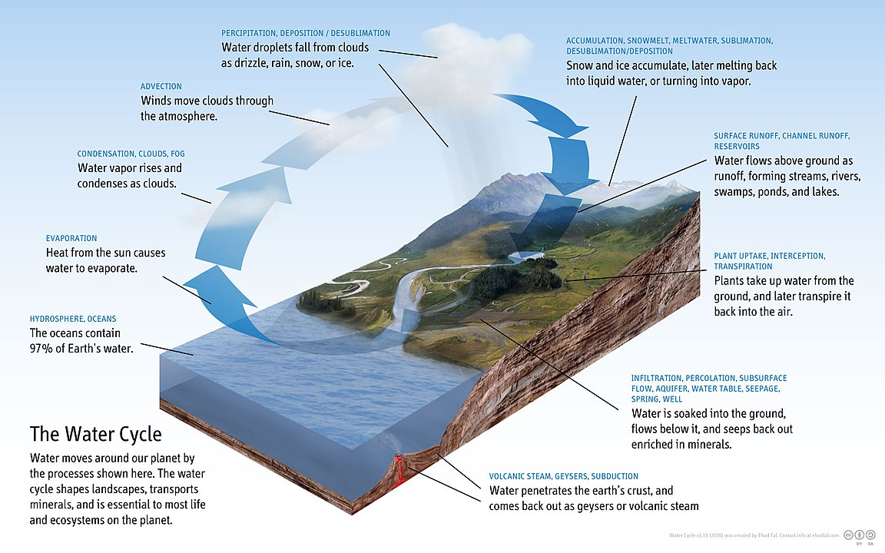
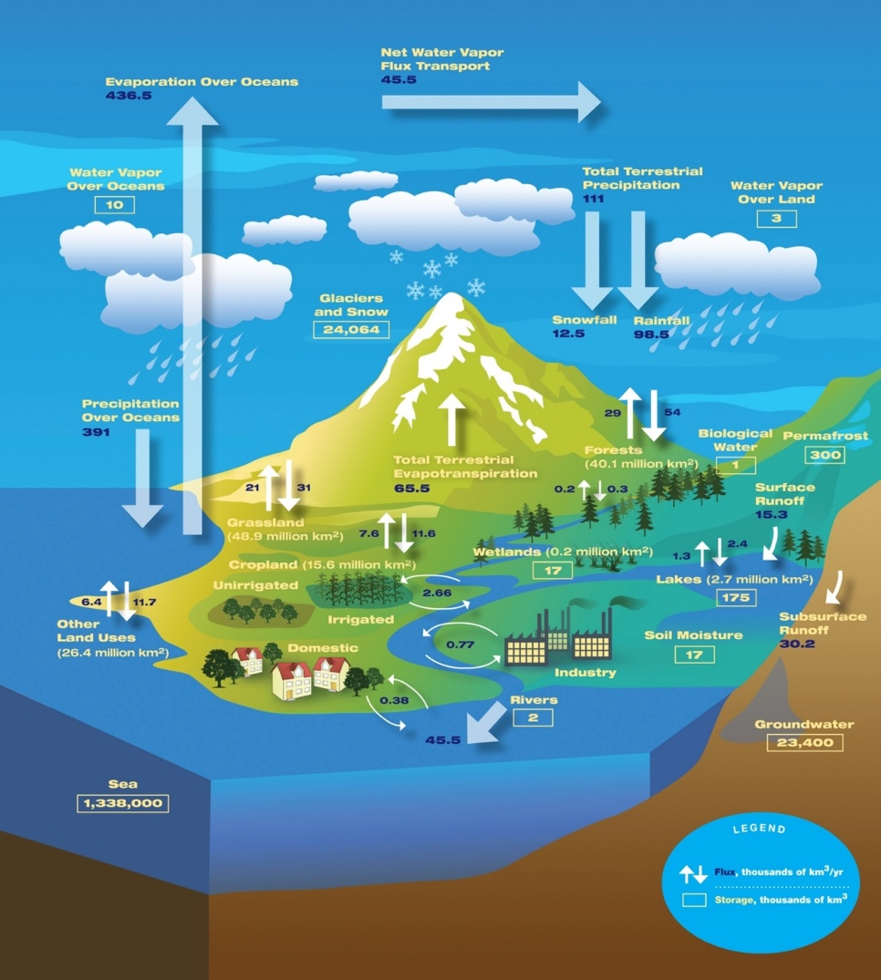
Figure A-1. Water cycle diagram. NASA/JPL Flickr (CC BY 2.0).
Figure A-2. Water Cycle diagram. Ehud Tal - Own work, CC BY-SA 4.0, https://creativecommons.org/licenses/by-sa/4.0.

Appendix B: Snapshot ecological summary of the major basins in the Mid-Coast.

Salmon River Ocean Drainage Area
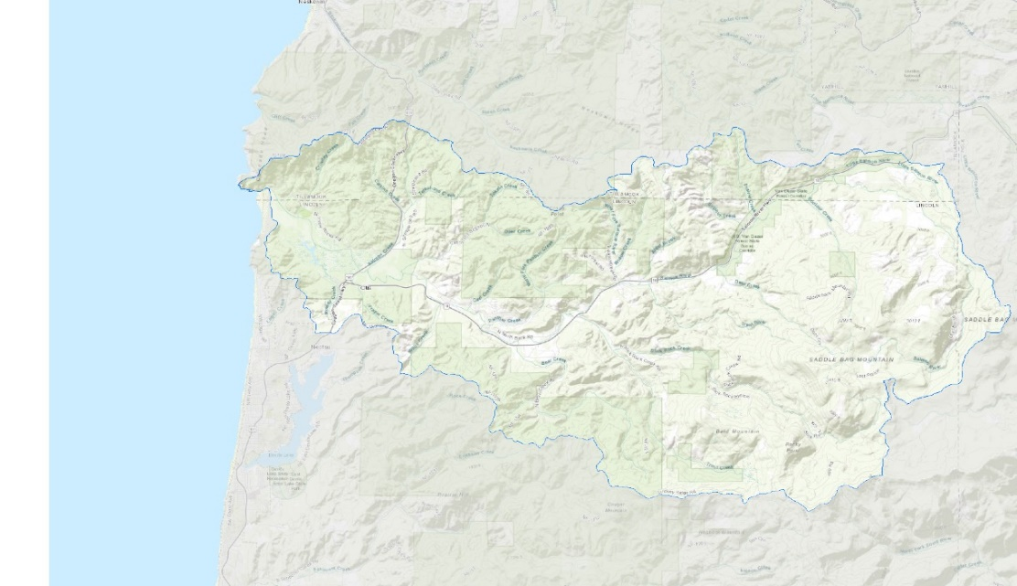
Key Sub Areas
Small water provider vulnerabilities –Panther Creek Watershed District, Guptil subdivision
Aging septic systems in Panther Creek Watershed.
Instream flow deficits.
Water quality limited streams that do not meet beneficial use criteria.

Key Sub-Area States
Pollution in Panther Creek (PC Water District Source Water Assessment); Salmon River water quality listed for fecal coliform; Panther Creek has E. coli spikes (Salmon Drift Creek Watershed Council)
Coastal Cutthroat Trout, Fall Chinook, and Winter Steelhead are OCS strategy species; Chum are sensitive critical (ODFW); Coho federally threatened (ESA); Pacific Lamprey are sensitive (ODFW)
Salmon River estuary and watershed are within Salmon River Estuary-Cascade Head Conservation Opportunity Area; State-recognized Important Bird Area

Key diversions/users
- Panther Creek Water District (700)—Source: Panther Creek, then GW 3
- Salmon River Mobile Village (75)—Source: GW
- Salmon River RV Park (69)—Source: GW
- Hiland WC Westwood (120)—Source: GW
- Hiland WC-Riverbend Park Water System (172)—Source: Duncan and Noname Creeks
- Hiland WC-Echo Mountain Park (362)—Source: GW
- Hiland WC-Boulder Creek (350)—Source: GW
- Hiland WC-Bear Creek (275)—Source: GW, Callow Creek
- Guptil Subdivision (28)—Source: GW (runs out of water in summer; looking for new source)
Instream flow stream deficits (ODFW)
Salmon River, Deer Creek, Salmon Creek, Bear Creek, Sulphur Creek, Panther Creek, and portions of Slick Rock Creek and Salmon River
High priority WABs for streamflow
- Salmon Creek at Mouth (WAB 01010)
- Panther Creek at Mouth (WAB 010310)
- Bear Creek at Mouth (WAB 010320)
- Salmon River above Slick Rock Creek (WAB 010340)
- Sulphur Creek at Mouth (WAB 010341)
Water quality limited streams that do not meet beneficial use criteria (ODEQ)
- Crowley Creek (Temperature)
- Deer Creek (Biological criteria)
- Salmon River (Dissolved oxygen, fecal coliform, temperature.

Siletz Bay Ocean Drainage Area
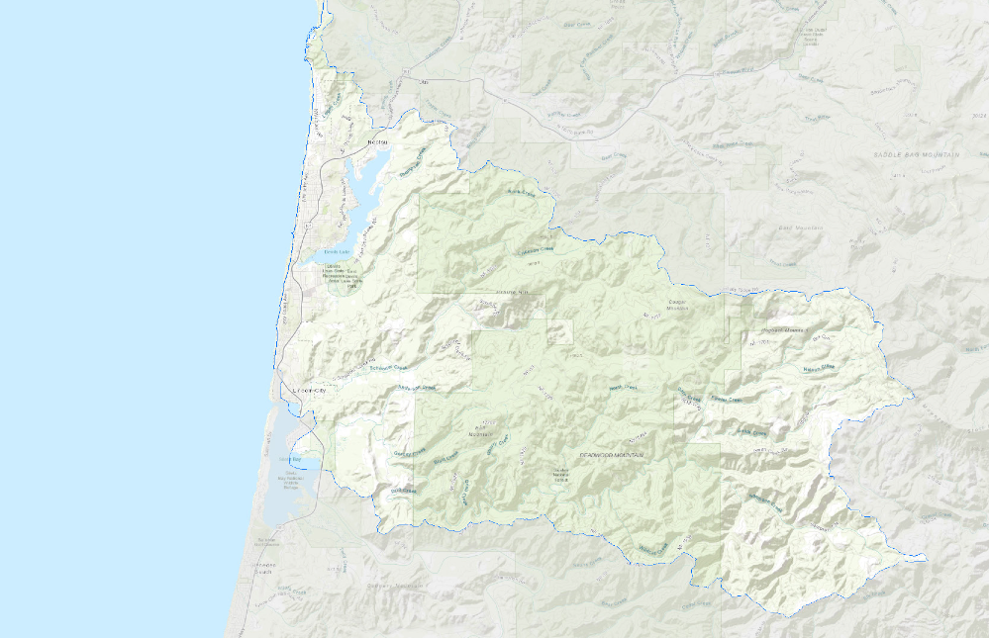
Key Sub Areas
- Water quality in Devil’s Lake watershed.
- Aging infrastructure in Devil’s Lake.
- Lack of interconnections and Kernville- Gleneden Beach- Lincoln Beach Water District has insufficient water treatment plant capacity.
- Diversion and turbidity issues on Schooner Creek.
- Diversions on Drift Creek.
- Lincoln City WWTP Discharge Location—Schooner Creek RM 1.1.

Key Sub-Area States
- Unnamed stream, tributary to Devil’s Lake listed as water quality limited for aquatic weeds or algae, chlorophyll a, and pH; Algal blooms in Devil’s Lake.
- Coho federally threatened (ESA); Fall Chinook, Winter Steelhead, and Pacific, Brook, and River Lamprey listed as sensitive (ODFW); Green Sturgeon Southern Distinct Population Segment listed as threatened (ESA); White Sturgeon (OCS)
- Devil’s Lake Watershed is a part of the Devil’s Lake Conservation Opportunity Area (ODFW); Drift Creek Area is a part of the Siletz River Conservation Opportunity Area, Moolack Frontal is an area of ecological importance (OCS).

Key diversions/users
- Lincoln City’s sole source of water is Schooner Creek (water rights for up to 16.5 cfs). A 2nd water intake occurs on Drift Creek – City has 1.0 cfs of certified water rights, which it can use only when withdrawals from Schooner Creek cannot meet demand.
- Kernville-Gleneden-Lincoln Beach Water District has water rights for up to 5.5 cfs on Drift Creek and up to 2.0 cfs on an unnamed tributary to Drift Creek (which it can use only in lieu of the district’s other rights during high turbidity events on Drift Creek and only from October 15 to May 15).
Instream flow deficits
- Schooner Creek, Drift Creek, and Rock Creek (ODFW) where instream rights occur
- Erickson Creek, Schooner Creek, Drift Creek, and D-River, where proposed instream water rights occur.
High Priority WABs for Streamflow
Schooner Creek at Mouth (WAB-030) and Drift Creek at Mouth (WAB-040) are highest, followed by D-River at Mouth (WAB 020)—high.
Water quality limited streams that do not meet beneficial use criteria (ODEQ)
- Unnamed Stream / Devils Lake-Aquatic Weeds or Algae; Chlorophyll a; pH.
- Rock Creek—Temperature
- Thompson Creek—Fecal Coliform
- Schooner Creek (near Lincoln City)—E. Coli; Temperature
- South Fork Schooner Creek—Temperature
- Drift Creek-Temperature; Biological Criteria
- Pacific Ocean—D River: Enterococcus

Siletz River Ocean Drainage Area
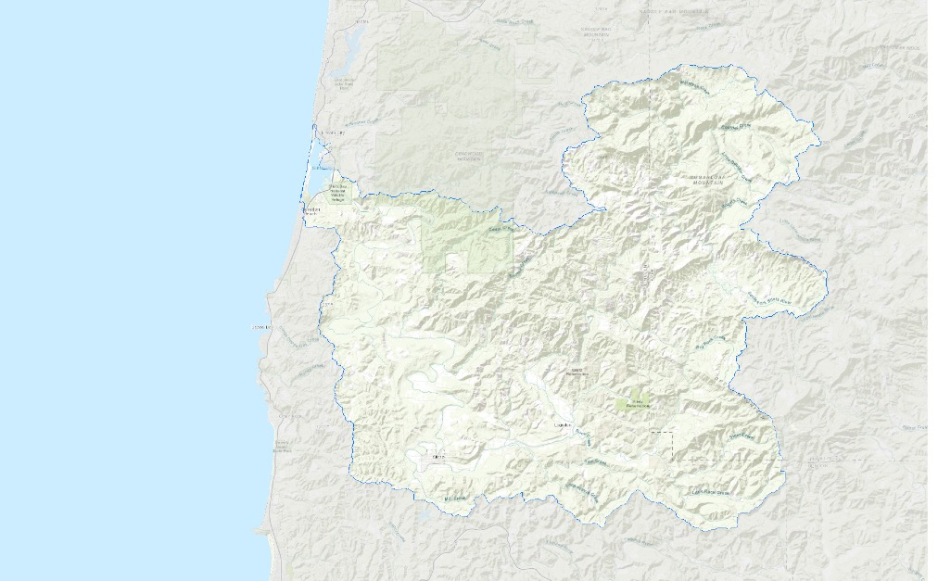
Key Sub Areas
Reduced water quality in the Siletz River
City of Newport:
Water loss in city systems.
Public safety concern—Big Creek Dam (high hazard earthen dam).
WWTP produces Class A biosolids that can be sold, or land applied without restriction
City of Toledo:
A percentage of non-revenue water in city systems
Wastewater treatment plant deficiencies
Mill Creek: Excess temperatures, Diversion and conveyance infrastructure needs to be repaired and replaced.

Key Sub-Area States
A. Coho federally threatened (ESA); Fall Chinook, Spring Chinook, Chum, Summer Steelhead, Winter Steelhead, Cutthroat Trout, Pacific Lamprey.
B. Siletz River, Middle Siletz, and Lower Siletz are critical habitat for Oregon Coast Coho Salmon (NMFS). A large portion of the Siletz River watershed is a Conservation Opportunity Area (COA) (ODFW).
C. High turbidity during winter months (the City of Newport to shift water sources from the Siletz River to Big Creek).
- Annual water loss in the City of Newport (19.88% in 2006).
- Annual non-revenue water in the City of Toledo (21.9% in 2015).
- Sanitary sewage overflows during heavy rainfall (Nov-Feb) caused by high levels of inflow and infiltration within the collection system.
- Algal blooms in Mill Creek Reservoir during the summer and Fall prevent the City of Toledo from using water.
- Diversion and conveyance infrastructure in the Mill Creek watershed need to be repaired and replaced.

Key Diversions/Users
- City of Newport (sources of water are Siletz River [6 cfs water rights] and Big Creek [10 cfs water rights])
- Seal Rock Water District (source of water is the City of Toledo – Siletz River). A 12-inch water line connects the District to the City of Newport to provide the city water in an emergency. SRWD also has water rights in the Beaver Creek-Ocean Tributaries drainage area on Henderson Creek, Hill Creek, and Beaver Creek.
- City of Siletz (source of water is the Siletz River). Sends water to Seal Rock Water District through one pipeline.
- City of Toledo (sources of water are the Siletz River and Mill Creek watershed [except in summer and Fall – algae]). Treats water for Seal Rock Water District.
- Georgia Pacific Mill (source of water is Olalla Reservoir on West Fork of Olalla Creek – stores water from Siletz River for plant in Toledo. Maintains tidegate at RM 0.8 on Olalla Creek to prevent upstream flow of salt water from Yaquina River.
- Lower Siletz Water System
- Carmel Beach Water District
D1. Interconnections:12-inch water line connects SRWD to City of Newport for emergency water. Booster station at intertie allows Newport to feed all of SRWD; only south of Yaquina Bay can be fed from SRWD.
Instream flow deficits occur streams with existing water rights: Bear Creek, Cedar Creek, Euchre Creek, Gravel Creek, Mill Creek, Rock Creek, South Fork Siletz River, Sam Creek, Siletz River #1, North Fork Siletz River, Little Rock Creek (ODFW). Proposed instream water rights occur on streams with instream flow deficits (ODFW): bold above and Siletz River #2, Buck Creek, Sunshine Creek, Gravel Creek.
High Priority WABs for Streamflow
Siletz River at mouth (WAB 050), Mill Creek at mouth (WAB 04043.
Water quality limited streams that do not meet beneficial use criteria (ODEQ)
- Cerine Creek—temperature
- Mill Creek—temperature
- North Creek—temperature
- Anderson Creek—temperature, biological criteria
- Siletz River—DO, temperature, turbidity
- South Fork Siletz River—biological criteria, temperature
Infrastructure Issues
- City of Newport Big Creek Dam is a high hazard earthen dam.
- City of Toledo wastewater treatment plant not operating as designed and has reduced capacity during winter months, affecting Yaquina River.
- City of Toledo needs to rebuild Mill Creek pump station and transmission piping; refurbish storage tanks; replace station force main; repair pipelines; rehabilitate manhole.
- City of Siletz—wastewater overflow events during winter heavy rainfalls.

Depoe Bay Ocean Drainage Area
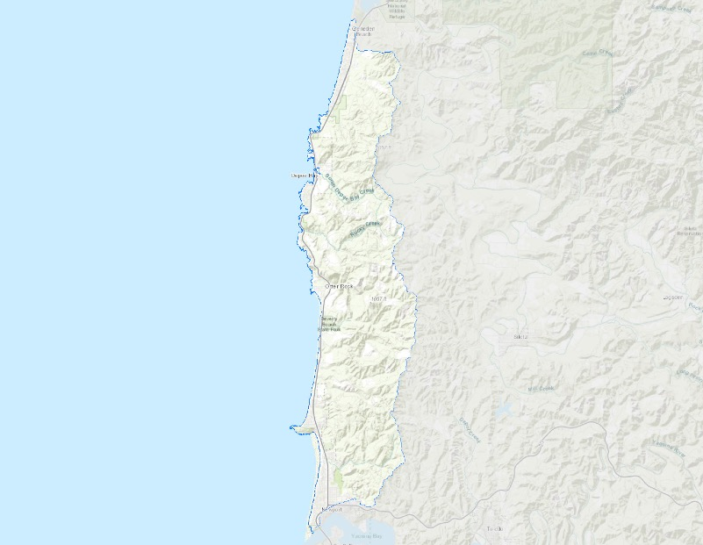
Key Sub-Area States
Key Diversions
Bay Hills Water Association (near Newport): source water is intermittent stream dam and improved springs. No additional taps permitted; insufficient water source in summer. Water association run by volunteers.
Beverly Beach Water District (near Newport)—source water is Wade Creek—need qualified plant operator and treatment staff.
City of Depoe Bay: source water is South Depoe Bay Creek, North Depoe Bay Creek, and Rocky Creek. When WTP capacity is insufficient to meet demands, the City meets the shortfall by relying on water from the recently built North Reservoir on North Depoe Bay Creek.
Inn at Otter Crest: source water is Johnson Creek. System is on septic.
Johnson Creek Water Service: source water is Johnson Creek. Water is sold to Sea Crest. System is on septic.
Otter Rock Water District: source water is 2 permanent springs and 1 seasonal spring. System is on septic.
Sea Crest: Purchases water supply from Johnson Creek Water Service, which uses Johnson Creek as a source.

High Priority WABs for Stream Flow
Depoe Creek at mouth (WAB 220)

Water quality impairments
- Beverly Beach—Enterococcus
- Agate Beach—Enterococcus

Key infrastructure issues
- City of Depoe Bay’s WWTP operates at 47% capacity (treats water from Gleneden Sanitary District); no sanitary sewer overflows since permit renewal in 2003.
- City of Depoe Bay’s WTP cannot produce enough finished water to meet MDD.
- New North Reservoir has alleviated issue in short-term.

Yaquina River Ocean Drainage Area
Key Sub-Areas
Deficiencies in City of Toledo Wastewater Treatment Plan
Insufficient water source for Bay Hills Water Association
Fecal coliform in Yaquina River Drainage Area, including 42 miles of Yaquina River having insufficient water treatment plant capacity.

Key Sub-Area States
A. WWTP discharges into the Yaquina River at River Mile 13.7. The WWTPO is not operating as designed (has diminished capacity in the winter) and the outfall pipe to the Yaquina River does not have sufficient capacity. The wastewater system has excessive inflow and infiltration. No additional taps permitted for Bay Hills Water Association. A total of 50.6 miles of streams are listed for fecal coliform in the Yaquina River drainage area.
B. Fall Chinook, Chum, Coho, Pacific Lamprey, Winter Steelhead, White Sturgeon, Green Sturgeon, Coastal Cutthroat Trout
C. Yaquina Bay, Big Elk Creek, and Yaquina River are critical habitat for Coho. Mill Creek has the most southern, stable populations of Chum salmon on the coast.

Key diversions/users
Bay Hills Water Association system is on septic, reservoir intercepts intermittent stream (unnamed stream, tributary to Yaquina River).

Instream flow deficits on streams with existing instream water rights
Elk Creek, Little Elk Creek, Simpson Creek, Yaquina River, Grant Creek, Feagles Creek, Deer Creek, Bear Creek, Mill Creek, and Olalla Creek. Instream flow deficits on streams with proposed instream water rights: Olalla Creek, Simpson Creek, Bear Creek, Big Elk Creek, Deer Creek, and Little Elk Creek.

High Priority WABs for Streamflow
Olalla Creek at mouth (WAB 0601); Mill Creek at mouth (WAB 0602); Elk Creek above Grant Creek (WAB 060323); Feagles Creek at mouth (WAB 0603231); Yaquina River above Elk Creek

High Priority WABs for Streamflow
(WAB 0604); Simpson Creek at mouth (WAB 06041); Little Elk Creek at mouth (WAB 0604211); Yaquina River above Bales Creek (WAB 0604212)

Water quality limited streams that do not meet beneficial use criteria
- Big Elk Creek—Dissolved oxygen, E. coli
- Boone Slough—Aquatic weeds or algae
- Depot Creek—DO
- Depot Slough—Fecal coliform
- Feagles Creek—E. coli, temperature
- Nute Slough —aquatic weeds or algae; fecal coliform
- Olalla Creek—Fecal coliform
- Poole Slough—Fecal coliform
- Spout Creek—temperature
- West Olalla Creek—temperature
- Yaquina River—DO, E. coli, Fecal coliform, temperature
- Montgomery Creek—Biological criteria
- Nye Beach—Enterococcus

Beaver Creek Ocean Drainage Area
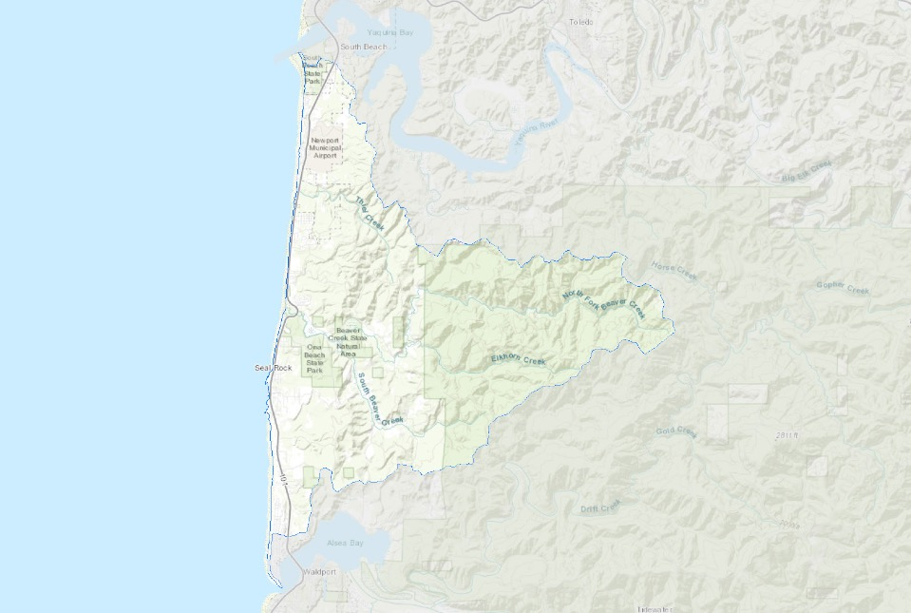
Key Sub-Area States
A. Coho federally threatened (ESA); Fall Chinook (sensitive—ODFW), Pacific Lamprey (sensitive—ODFW), Winter Steelhead (sensitive—ODFW).
B. Entire watershed is within Beaver Creek Conservation Opportunity Area (ODFW). Protected areas include Beaver Creek State Natural Area, Drift Creek Wilderness, Estella Matilda Happ Preserve, Ona Beach State Park, Seal Rock Wetland Preserve, and Siuslaw National Forest.

Key diversions/users
Riverside Mobile Park – source is a well. Wastewater system infrastructure unknown.

No existing instream water rights.
Proposed instream water rights occur on streams with instream flow deficits (ODFW): North Fork Beaver Creek

Water quality limited streams that do not meet beneficial use criteria (ODEQ)
- Oliver Creek-Biological Criteria
- North Fork Beaver Creek-Biological Criteria; E. Coli; Temperature; Dissolved Oxygen
- South Fork Beaver Creek-Temperature; pH; E. Coli; Dissolved Oxygen
- Beaver Creek-Dissolved Oxygen

Alsea River Ocean Drainage Area
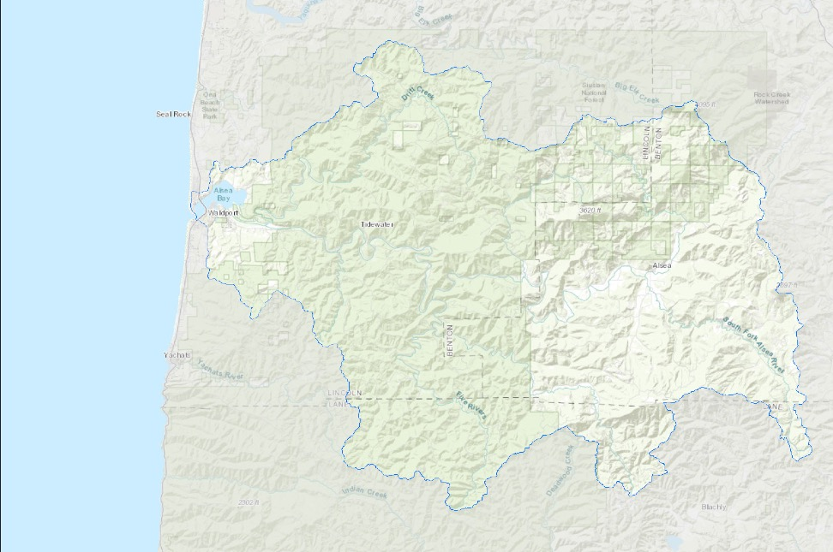
Key Sub-Area
- Excess temperatures in streams in Alsea River drainage.
- Water quality impairments on Alsea River.

Key Sub-Area States
A. 216.9 miles of Alsea River Drainage area streams are listed for temperature impairments. Water quality impairments on the Alsea River include DO, fecal coliform, and temperature.
B. Coho; Fall Chinook, Spring Chinook, Chum, Summer Steelhead, Winter Steelhead, Coastal Cutthroat Trout, Pacific Lamprey, Green Sturgeon.
C. Alsea Bay is a Conservation Opportunity Area (COA) (ODFW).

Key diversions/users
- Eddyville Charter School has a well; lead and copper rule violation.
- Fall Creek Water district has 3 source wells; system on septic; groundwater is for household use only; District has water right on Alsea River for lawn irrigation.
- Kozy Acres Water System has 2 source wells; system is on septic.

Instream flow deficits
on streams with existing instream water rights: Alsea River, Bummer Creek, Drift Creek, Fall Creek, Five Rivers, Green River, Lobster Creek, North Fork Alsea River, South Fork Alsea River. Proposed instream water rights occur on streams with instream flow deficits (ODFW): Drift Creek, Mill Creek, Canal Creek, Scott Creek, Grass Creek, Fall Creek, Cascade Creek, Buck Creek, Green River, Five Rivers #1, Five Rivers #2, Five Rivers #3, Lobster Creek #1, Lobster Creek #2, Little Lobster Creek, Little Lobster Creek #2, Preacher Creek, Fall Creek, North Fork Alsea River, South Fork Alsea River, Alsea River, Crooked Creek, Honey Grove Creek, Bummer Creek.
High Priority WABs for Streamflow
Lobster Creek at mouth (WAB 08021111), Five Rivers above Green River (WAB 080211121), Bummer Creek at mouth (WAB 08021221)
Water quality limited streams that do not meet beneficial use criteria (ODEQ)
- Alsea River-Dissolved Oxygen; Fecal Coliform; Temperature
- Preacher Creek-Temperature
- South Fork Alsea River-Temperature
- South Fork Lobster Creek-Temperature
- North Fork Alsea River-Temperature
- Lobster Creek-Temperature
- Little Lobster Creek-Temperature
- Bummer Creek-Temperature
- Buck Creek-Temperature
- Green River-Temperature
- East Fork Green River-Temperature
- Five Rivers-Temperature
- Fall Creek-Temperature
- Drift Creek-Temperature
- Fall Creek-Temperature
- Bailey Creek-Habitat Modification
- Flynn Creek-Biological Criteria; Temperature
- Meadow Creek-Temperature
- Gopher Creek-Temperature
- Cascade Creek-Temperature
- Canal Creek-Fecal Coliform
- Camp Creek-Temperature
- Peak Creek-Temperature
- Phillips Creek-Temperature
- North Fork Cascade Creek-Temperature

Yachats River Ocean Drainage Area

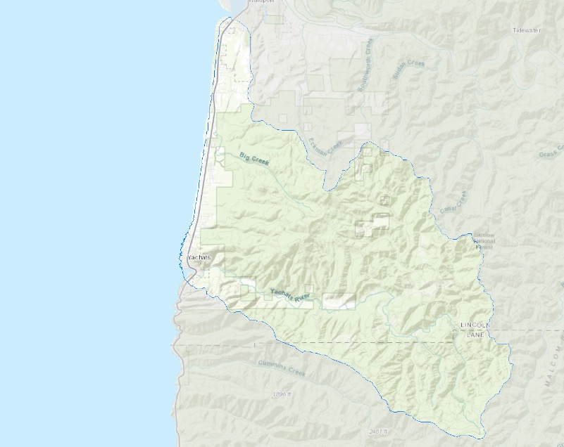
Key Sub-Areas
- Yachats River streamflow insufficient
- Yachats River instream temperature excessive for salmon and steelhead
- City of Yachats water demand fluctuates significantly
- Non-revenue water is 40% for City of Yachats (1997- 2000 average)
Key Sub-Area States
A. City of Yachats water service area population of 600 can reach peak of 2,500 in summer.
B. Coho; Fall Chinook, Steelhead, Coastal Cutthroat Trout, Pacific Lamprey.
C. Yachats River Watershed is designated as the Yachats River Conservation Opportunity Area (COA) (ODFW).
Key diversions/users:
- SW Lincoln County Water PUD water sources are Big Creek, Vingie Creek, Starr Creek (90% of water supply), and Dicks Fork Creek (10% of water supply)
- City of Waldport water sources are North and South Weist Creeks and Eckman Creek (also can receive/send water to/from SW Lincoln County Water PUD).
- City of Yachats source water is Reedy Creek and Salmon Creek (backup to Reedy). City has water rights on Yachats River and Cape Creek, but does not divert. Reedy and Salmon Creeks have insufficient flows during late summer to supply City’s water needs. Can receive/send water to/from SW Lincoln County Water PUD.
SW Lincoln County Water PUD can send/receive water to/from City of Waldport and City of Yachats.
Instream flow deficits
on streams with existing instream water rights: Yachats River, North Fork Yachats River, Williamson Creek, School Fork.
High Priority WABs for Streamflow
Yachats River at mouth (WAB 090), Yachats River above North Fork (WAB09011), and Yachats River above Beamer Creek (WAB 0901)
Water quality limited streams that do not meet beneficial use criteria (ODEQ)
- North Fork Yachats River—E. Coli; Temperature; Dissolved Oxygen
- Williamson Creek—Dissolved Oxygen; Temperature
- Yachats River—Temperature
- Alder Creek—Temperature
- Carson Creek—Temperature
- Beamer Creek—Dissolved Oxygen
- Stump Creek—Temperature; E. Coli; Dissolved Oxygen
- Keller Creek—Dissolved Oxygen; E. Coli; Temperature
- Depew Creek—Temperature
- Grass Creek—Temperature
- School Fork—Dissolved Oxygen; E. Coli; Temperature

Key Infrastructure Issues
- City of Waldport’s wastewater collection system is old - Inflow and infiltration problems.
- City of Waldport’s pipelines are older galvanized iron, steel, and asbestos cement in sections—Frequently replaced due to poor condition (leakage, corrosion, loss of capacity).
- City of Yachats AC piping in poor condition—frequently replaced due to poor condition.
WWTP required maintenance; new WWTP experienced loss of electrical power to one of the pump stations—Resulted in overflow events

Appendix C: Crosswalk of the Mid-Coast Water Planning Partnership Plan actions with other important regional conservation plans

 |  | MCWPP WATER ACTION PLAN STRATEGIES
ENDANGERED SPECIES ACTION FEDERAL COHO RECOVERY PLAN ACTIONS | MCS-1 (Tributaries), MCS-21 and MCS-22 (Mainstems): Increase harvest buffers on private industrial timberlands, reduce road densities on private and federal timberlands. | 46
ENDANGERED SPECIES ACTION FEDERAL COHO RECOVERY PLAN ACTIONS | MCS-7 and MCS-8 (Tributaries), MCS-31 and MCS-32 (Mainstems): Conduct riparian planting projects on streams in agricultural lands. | 50, 52
ENDANGERED SPECIES ACTION FEDERAL COHO RECOVERY PLAN ACTIONS | MCS-11 and MCS-13 (Tributaries), MCS-29 (Mainstems): Develop water conservation strategies for municipal and irrigation water withdrawals to improve water quality. | 6, 7,
ENDANGERED SPECIES ACTION FEDERAL COHO RECOVERY PLAN ACTIONS | MCS-12 and MCS-14 (Tributaries): Improve water quality by improving stream shade, and substrate retention. | 50, 52
ENDANGERED SPECIES ACTION FEDERAL COHO RECOVERY PLAN ACTIONS | MCS-17 and MCS-18 (Off-channel and wetlands): Increase beaver pond abundance. | 5, 35, 51
ENDANGERED SPECIES ACTION FEDERAL COHO RECOVERY PLAN ACTIONS | MCS-19 and MCS-20 (Wetlands): Reduce existing/limit channel-confining structures, including roads and infrastructure, in the floodplain that disconnect wetlands from tributaries. | 50
ENDANGERED SPECIES ACTION FEDERAL COHO RECOVERY PLAN ACTIONS | MCS-25 and MCS-26 (Mainstems): Increase large wood and marginal and streambank habitat structure. | 50, 52
ENDANGERED SPECIES ACTION FEDERAL COHO RECOVERY PLAN ACTIONS | MCS-27 (Mainstems): Develop water conservation strategies for municipal and irrigation water withdrawals. | 24
ENDANGERED SPECIES ACTION FEDERAL COHO RECOVERY PLAN ACTIONS | MCS-28 and MCS-30 (Mainstems): Improve water quality by improving stream shade, and substrate retention. | 50, 52
ENDANGERED SPECIES ACTION FEDERAL COHO RECOVERY PLAN ACTIONS | MCS-35 (Estuary): Identify sources of water pollution and develop strategies to reduce pollutants in water discharges. | 13
OREGON WATERSHED ENHANCEMENT BOARD FOCUSED INVESTMENT PARTNERSHIP (AQUATIC HABITAT STRATEGIES) | Reconnect Floodplains | 46, 47, 51
 | Restore Stream Flow | 46, 47, 52, 53, 54, 55, 56, 57
 | Restore Habitat in Stream Channels | 46, 47, 48, 49, 50, 52
 | Road Repair or Decommission | 50
 | Riparian Restoration | 46, 47, 48, 49, 50, 52
 | Supporting Healthy Habitats | 37, 40, 42, 43, 44, 45, 46, 47, 48, 49, 50, 51, 52, 53, 54, 55, 56, 57, 58, 59, 60, 61
 | Control Invasive Weeds | 58
 | Easements and Acquisitions | 45, 60
LINCOLN COUNTY CLIMATE ACTION PLAN STRATEGIES | Public outreach and education | 1
LINCOLN COUNTY CLIMATE ACTION PLAN STRATEGIES | Metered water fixtures / conservation solutions | 3, 4, 6, 7, 14, 15, 24, 25, 26
LINCOLN COUNTY CLIMATE ACTION PLAN STRATEGIES | Rainwater harvesting systems | 22
LINCOLN COUNTY CLIMATE ACTION PLAN STRATEGIES | Incorporate water conservation features in new construction | 61
LINCOLN COUNTY CLIMATE ACTION PLAN STRATEGIES | Water audits and feasibility studies | 2
LINCOLN COUNTY CLIMATE ACTION PLAN STRATEGIES | Cost-share incentives | 25
LINCOLN COUNTY CLIMATE ACTION PLAN STRATEGIES | Educational curriculum for students and citizens | 1
LINCOLN COUNTY CLIMATE ACTION PLAN STRATEGIES | Incorporate green infrastructure | 5, 8
LINCOLN COUNTY CLIMATE ACTION PLAN STRATEGIES | Protect healthy landscapes | 12, 16, 17, 18, 19, 20, 21, 40, 42, 44, 45, 46, 47, 48, 49, 50, 51, 52, 53, 54, 55, 56, 57, 58, 59, 60, 61
LINCOLN COUNTY CLIMATE ACTION PLAN STRATEGIES | Restore degraded landscapes | 13
LINCOLN COUNTY MULTI-JURISDICTIONAL NATURAL HAZARDS MITIGATION PLAN | The Lincoln County Multi-Jurisdictional Natural Hazards Mitigation Plan describes priority natural hazards of concern to the Mid-Coast region, including coastal erosion, drought, earthquakes, floods, landslides, tsunamis, wildfire, windstorms, and winter ice. | 9, 10, 11, 50

Appendix D: Water providers by population served and connections

There are 52 water providers in the Mid-Coast region that deliver water to resident population of 60,877 people through 24,299 connections.

Alsea
- Fall Creek Water District
Blodgett
- Bless Your Heart Baking and Cafe
- Fir Ridge Campground
Depoe Bay
- City of Depoe Bay
Gleneden Beach
- Kernville-Gleneden-Lincoln Beach Water District
Lincoln City
- Lincoln City Water District
- Oregon Parks and Recreation Department HB Van Duzer State Park
- Lower Siletz Water System
- Calkins Acres Improvement Inc.
​Newberg
- Sea Crest
​Newport
- City of Newport
- Oregon Parks and Recreation Department Ellmaker State Park
- Oregon Parks and Recreation Department Beverly Beach State Park
- Beverly Beach Water District
- Otter Rock Water District
- Bay Hills Water Association
- Carmel Beach Water District
- Lincoln County Parks - Moonshine Park
- Mad Dog Country Tavern
- Sawyers Landing RV Park

Otis
- Hiland WC - Echo Mountain, Boulder Creek, Bear Creek
- Westwind Stewardship Group
- Otis Junction Water system
- Salmon River Mobile Village
- Salmon River RV Park
- Lincoln City KOA
- Guptil Subdivision
Otter Rock
- Johnson Creek Water Service
- Inn at Otter Crest
Reedsport
- US Forest Service Cape Perpetua Visitor Center
Rose Lodge
- Hiland WC - Riverbend​
Seal Rock
- Seal Rock Water District
Sheridan
- Drift Creek Camp
Siletz
- City of Siletz
Tidewater
- Hiland WC - Westwood
- US Forest Service Blackberry Campground
Toledo
- Toledo Water Utilities
- Eddyville Charter School
- Olalla Valley Golf Course
Waldport
- City of Waldport
- Kozy Acres Water System
- Drift Creek Landing
- Taylors Landing RV Park
- Riverside Mobile Park
- King Silver RV Park
- Rovers RV Park
- Happy Landing RV Park/Marina
Yachats
- Southwest Lincoln County Water PUD
- City of Yachats

Appendix E: Mid-Coast Water Planning Partnership Step 2 Reports on Water Quality, Quantity, and Ecology in the Mid-Coast of Oregon

Appendix F. User’s Guide to Oregon Explorer

The other three areas include the Lower John Day Sub-basin, Upper Grande Ronde Sub-basin, and Malheur Lake Basin.
NMFS (National Marine Fisheries Service). 2016. Recovery Plan for Oregon Coast Coho Salmon Evolutionarily Significant Unit. National Marine Fisheries Service, West Coast Region, Portland, Oregon.
https://www.oregon.gov/oweb/grants/Pages/fips.aspx
https://www.co.lincoln.or.us/planning/page/natural-hazards-mitigation-plan
Note: Not all model runs resulted in the projected changes shown in the graphic; there were differences in model outputs for these parameters. However, this graphic illustrates likely Mid-Coast trends.
https://www.watercalculator.org/
https://www.epa.gov/sourcewaterprotection/basic-information-about-source-water-protection
(Eligible projects include but are not limited to outreach/education, monitoring efforts (outside of what is required by the state), restoration design and implementation, groundwater risk assessments. Publicly and privately-owned community and nonprofit non-community water systems are eligible to apply for DWSPF funding.
Invites proposals from high school organizations providing natural resources education. Funding is available for natural resource related tools, equipment, technology, and other educational resources.
Grants are awarded to smaller non-profit organizations; most often to groups with social service, arts, and culture, educational, environmental and/or youth-centered missions.
Eligible projects include but are not limited to outreach/education, monitoring efforts (outside of what is required by the state), restoration design and implementation, groundwater risk assessments. Publicly and privately-owned community and nonprofit non-community water systems are eligible to apply for DWSPF funding.
Will fund irrigation modernization projects for water efficiency if it benefits water quality.
https://www.epa.gov/sourcewaterprotection/basic-information-about-source-water-protection
Consider existing studies for additional water sources, such as the 2001 CH2MHill Report on the Rocky Creek Regional Water Supply Project and Preliminary Water Management Plan, and conduct an updated analysis of supply and demand (considering the Multi-jurisdictional Natural Hazard Mitigation Plan and other risks, e.g., cyber security).
(Oregon State University, Oregon Water Resources Department, and MCWPP are developing a Water Management Economic Assessment Model using existing water supply, pricing, and consumption data integrated with climate change projections to simulate the impact of future water shortages and illustrate trade-offs among potential adaptation measures.)
Community demonstration & capacity-building projects that help communities understand environmental risks and opportunities and organize and take actions to improve local resiliency by enhancing natural buffers and system functions.

